

**SMART CITY**

**APARTMENT SERVICES WEBSITE**

**Final Release Document**

– Ho Chi Minh City, May 2023 –

# **I. Table Of Contents**

**I. Table Of Contents** **2**

**II. Deliverable Package** **3**

**III. Installation Guides** **4**

**IV. User Manual** **4**

1. Overview 4

2. Workflow 5

1. Admin 5

1. The workflow for the admin to edit the admin's information 5

2. The workflow for the admin to tracking and managing data 5

3. The workflow for the admin to manage customer 6

4. The workflow for the admin to manage staff 7

5. The workflow for admins to view and manage blocked accounts 7

6. The workflow for admins to create new account 8

7. The workflow for admins to Service management 8

8. The workflow for admins to view and manage blocked services 9

9. The workflow for admins to create new service. 10

10. The workflow for admins to Appointment management 10

11. The workflow for admins to Blog management 11

12. The workflow for admins to create new Blog 11

2. Manager 12

1. The workflow for a manager for tracking and managing data 12

2. The workflow for a manager to edit personal information 12

3. The workflow for a manager to view a list of users. 13

4. The workflow for a manager to view a list of staffs. 14

5. The workflow for a manager to view a list of blocked Accounts. 15

6. The workflow for a manager to manage services. 16

7. The workflow for a manager to manage booking orders. 17

8. The workflow for a manager to manage blogs. 18

9. The workflow for a manager to create new account for any. 19

3. Staff 20

1. The workflow for the staff to edit the staff's information. 20

2. The workflow for the staff to view the service list. 21

3. The workflow for the staff to view the feedback. 22

4. Customer 23

1. Workflow customer order service 23

2. Workflow customer check order detail 23

3. Workflow customer update account information 24

4. Workflow customer feedback 25

5. Guest 26

1. The workflow for guests to view the home page. 26

2. The workflow for guests to view the services list. 27

3. The workflow for guests to view the blogs list. 28

4. The workflow for guests to view the blogs in detail and comment on each blog. 29

5. The workflow for guests to view and register members. 31

# **II. Deliverable Package**

| **No** | **File** | **Notes** |
| --- | --- | --- |
| 1 | G3_SC_DB_final.sql | Database, including both table structures and table data |
| 2 | G3_SC_SRS_final.docx | Final SRS (Requirement) Document |
| 3 | G3_SC_SDS_final.docx | Final SDS (Design) Document |
| 4 | G3_SC_Final Project Tracking.xlsx | Final status for the application functions, which include:  - Function name, feature, roles, function description (changes compared to the original requirements are highlighted)  - In Charge, Planned iteration & Actual iteration  - Final status & note on the update you made  - The links to the SRS & SDS are tracked |
| 5 | G3_SC_Issues Report.xlsx | Final issues tracking list of the whole project |

Other related deliverables:

● Tagged source codes: Link github (chỉnh sửa sau)

● Demonstration video: Link Youtube (chỉnh sửa sau)

● Link website:

# **III. Installation Guides**

● Environment install

- JDK 8:[Download here](https://www.oracle.com/java/technologies/javase/javase8-archive-downloads.html)

- Netbeans r8.2 : [Here](https://notesformsc.org/install-netbeans-ide-8-2-windows/) (version r8.2 is old and no longer supports downloading from Netbeans. Please download via the link : [here](https://www.shaileshjha.com/step-by-step-how-to-download-and-install-java-se-jdk-8-on-windows-10/))

- SQL Server: link SQL Server

● Database

- Create database name: Smart CIty DB

- Import database: G3_SC_DB_Final.sql

● Run Code

- Open code using netbeans 8.2

- Add server : using Apache Tomcat server

- Go to resource/database.properties – Edit url, username, password

- Run

# **IV. User Manual**

## **1. Overview**

* V-Home Clean System is a web booking system for customers, and cleaning staff. This system aims for a friendly interface that is easy to use and responds quickly

## **2. Workflow**

### **1. Admin**

#### 1. The workflow for the admin to edit the admin's information

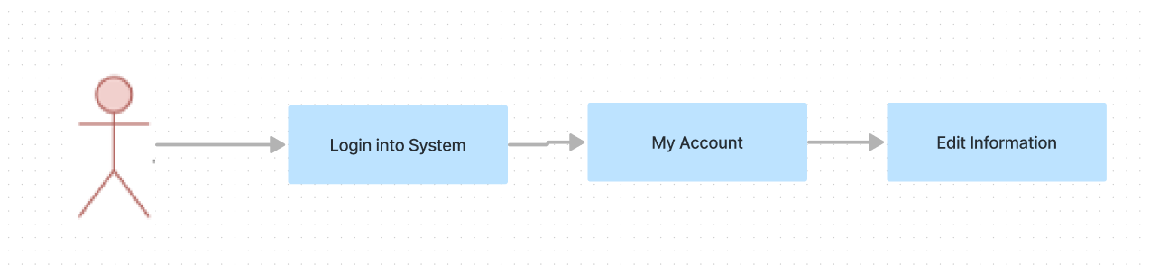

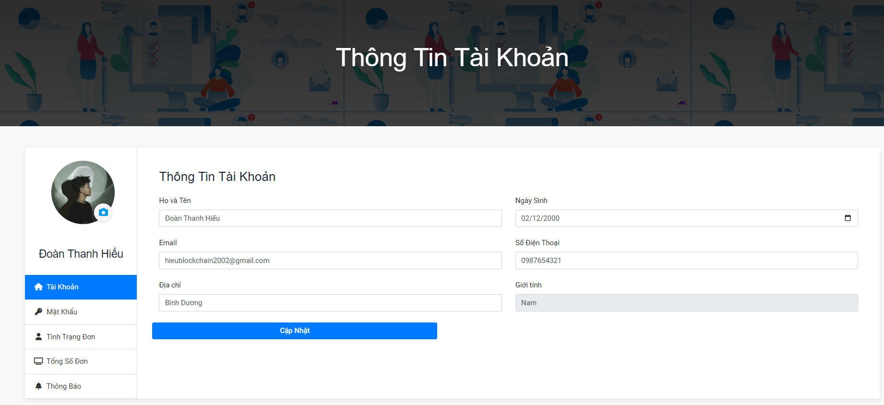

#### 2. The workflow for the admin to tracking and managing data

#### 

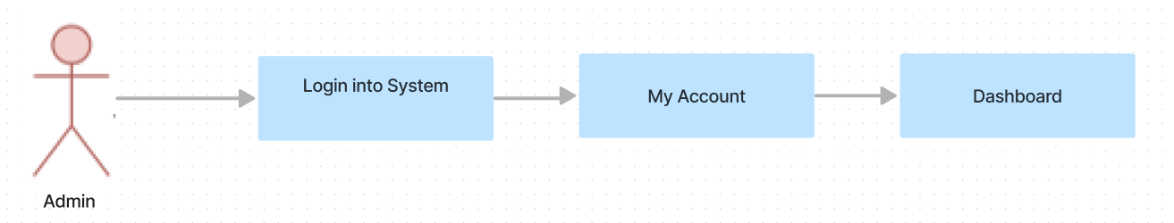

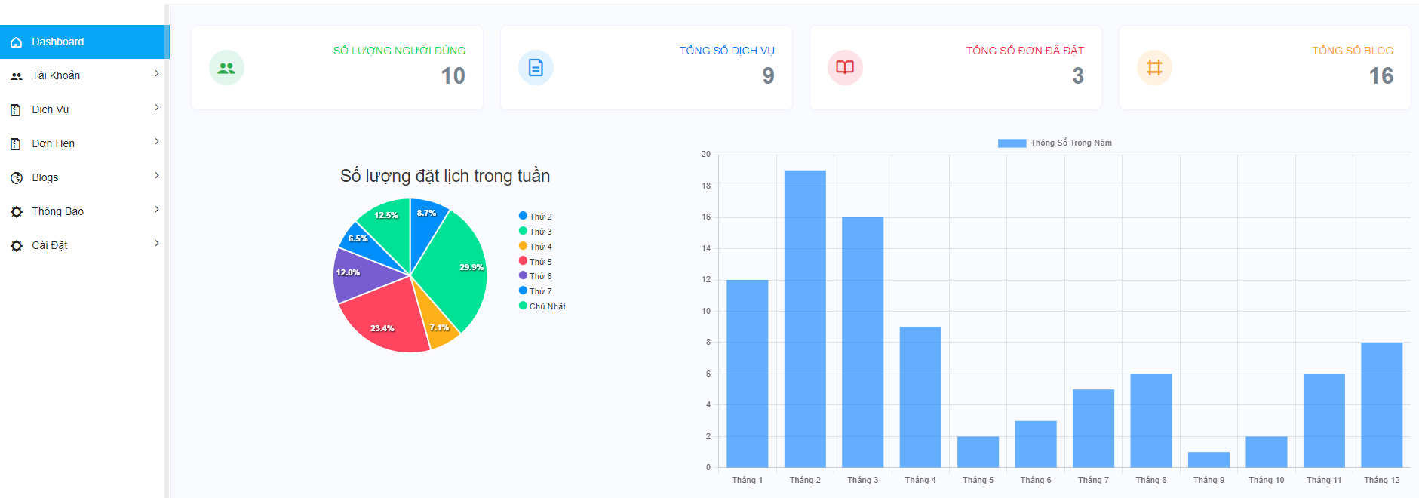

#### 3. The workflow for the admin to manage customer

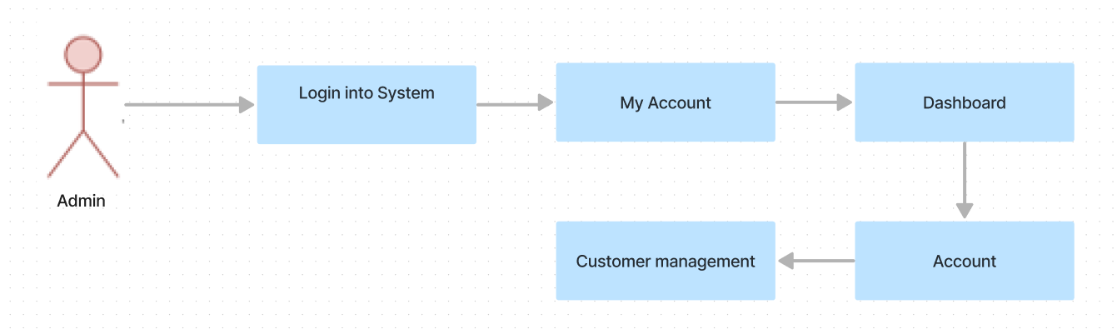

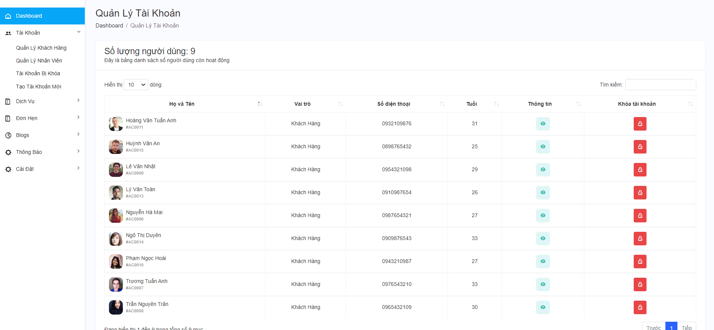

#### 4. The workflow for the admin to manage staff

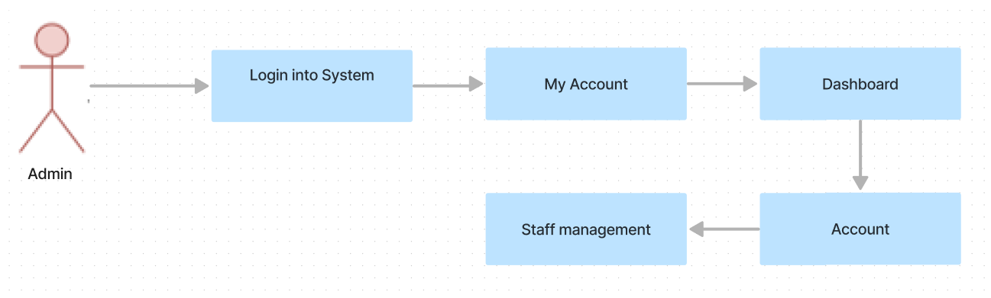

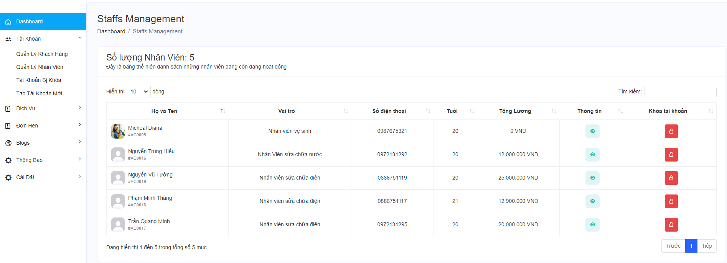

#### 5. The workflow for admins to view and manage blocked accounts

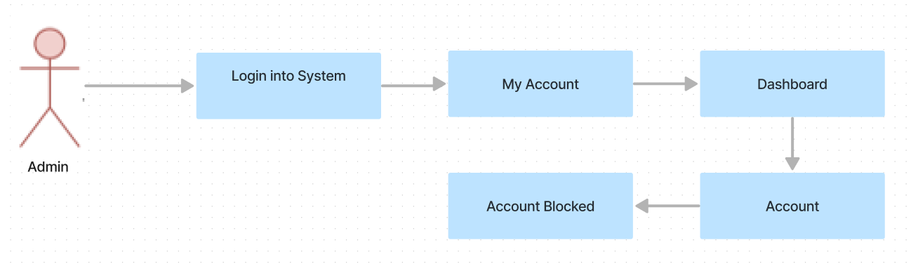

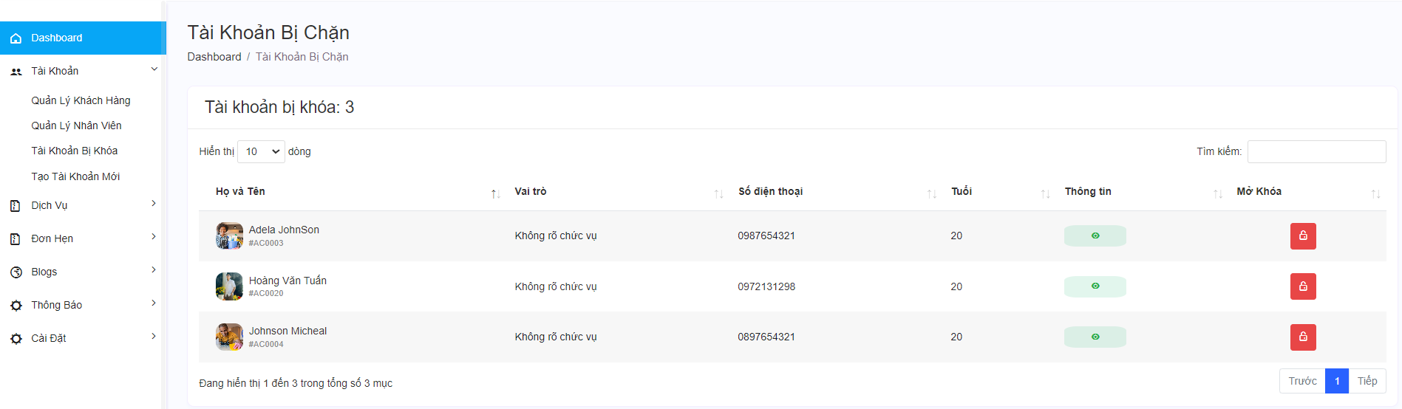

#### 6. The workflow for admins to create new account

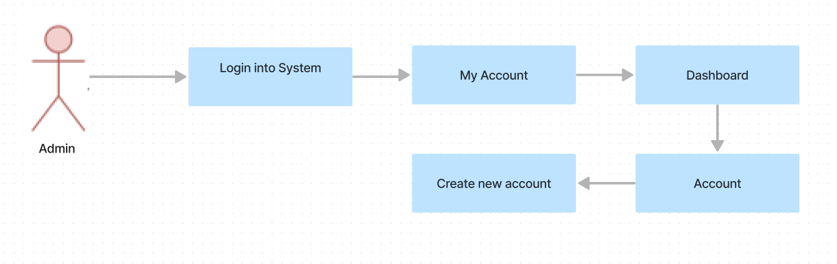

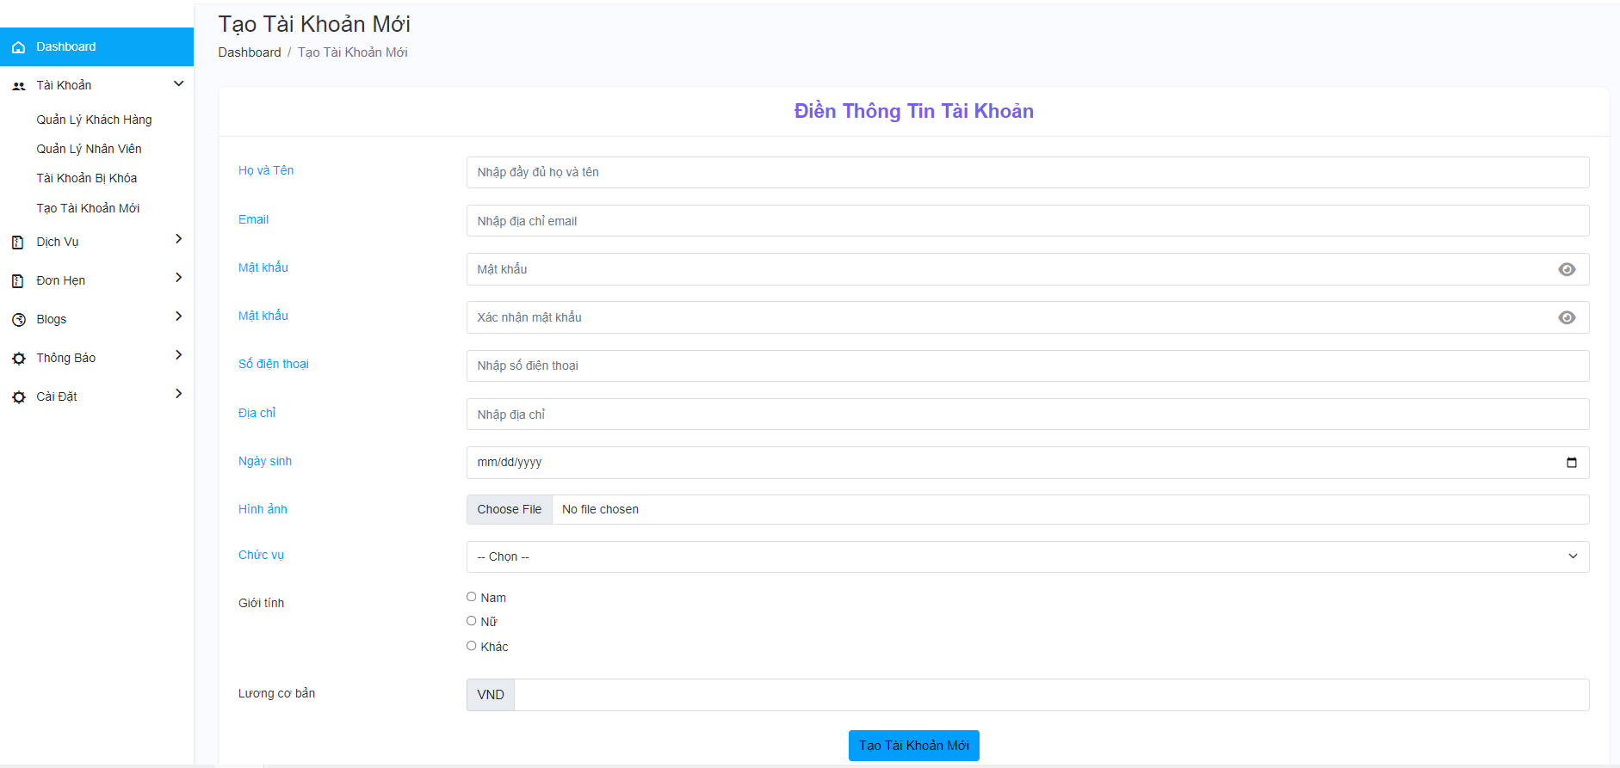

#### 7. The workflow for admins to Service management

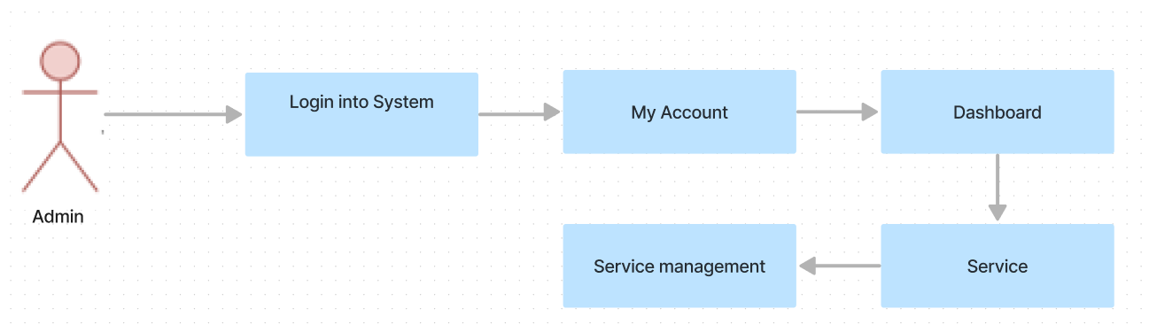

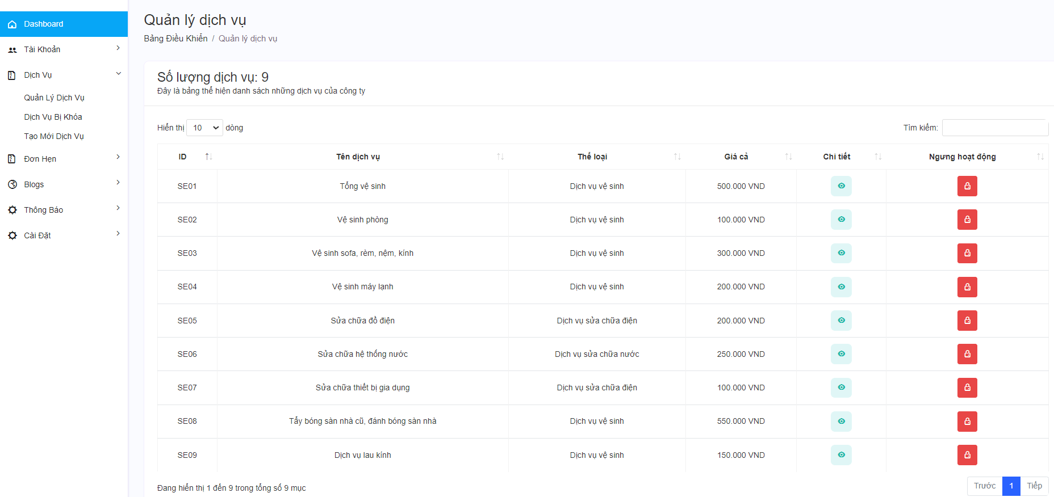

#### 8. The workflow for admins to view and manage blocked services

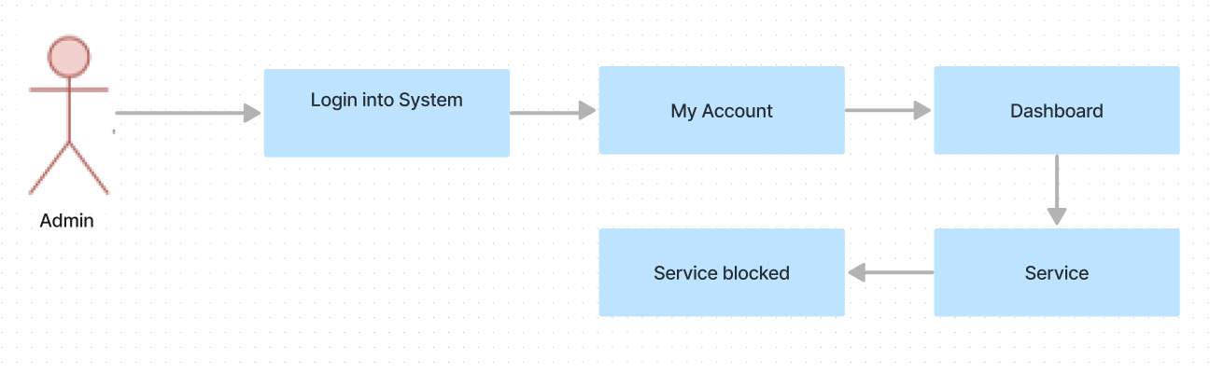

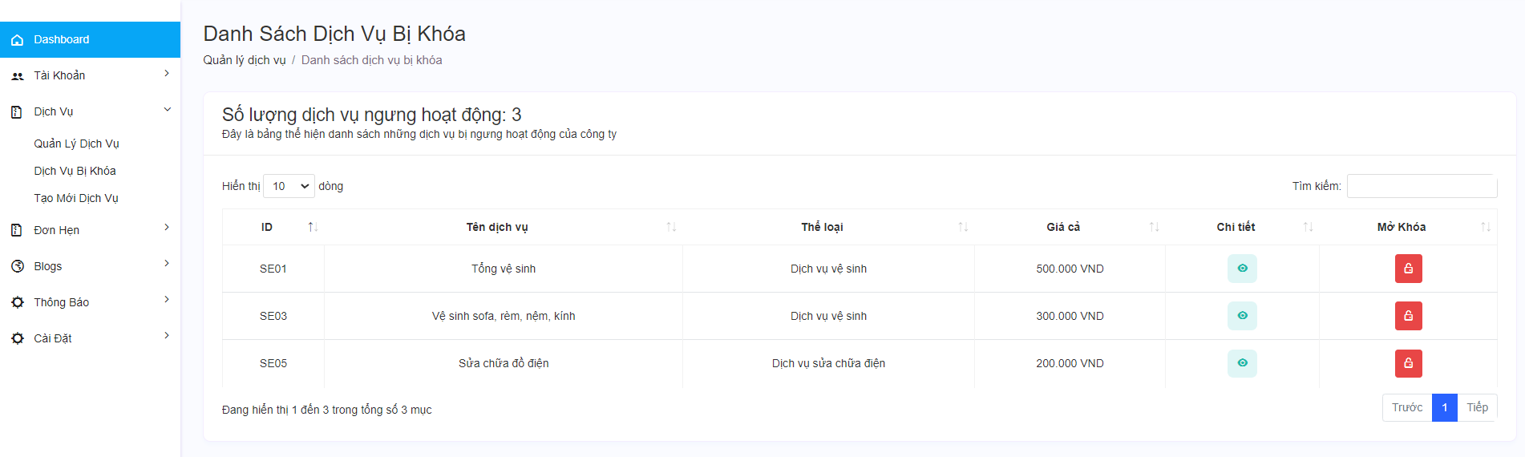

#### 9. The workflow for admins to create new service.

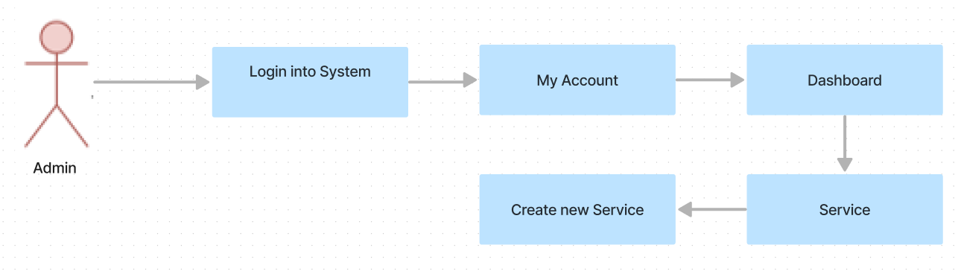

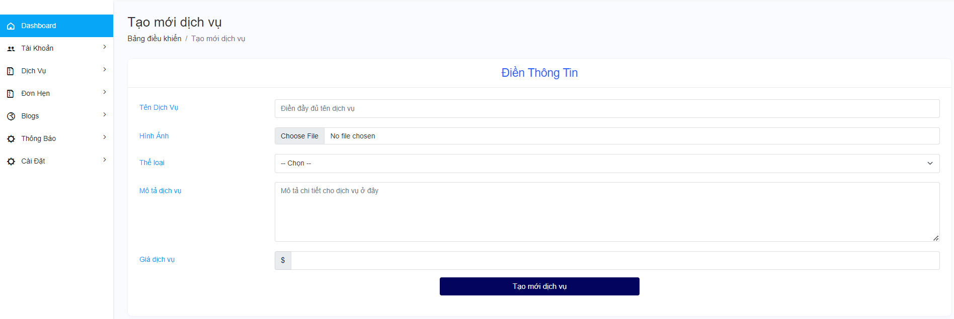

#### 10. The workflow for admins to Appointment management

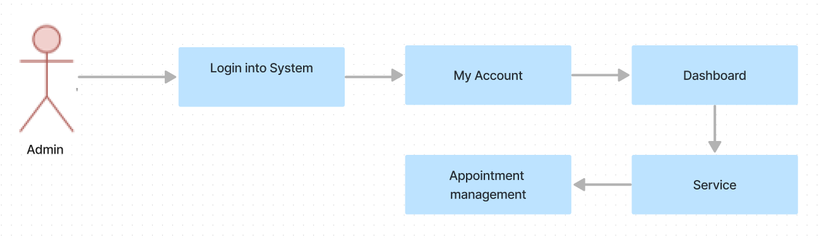

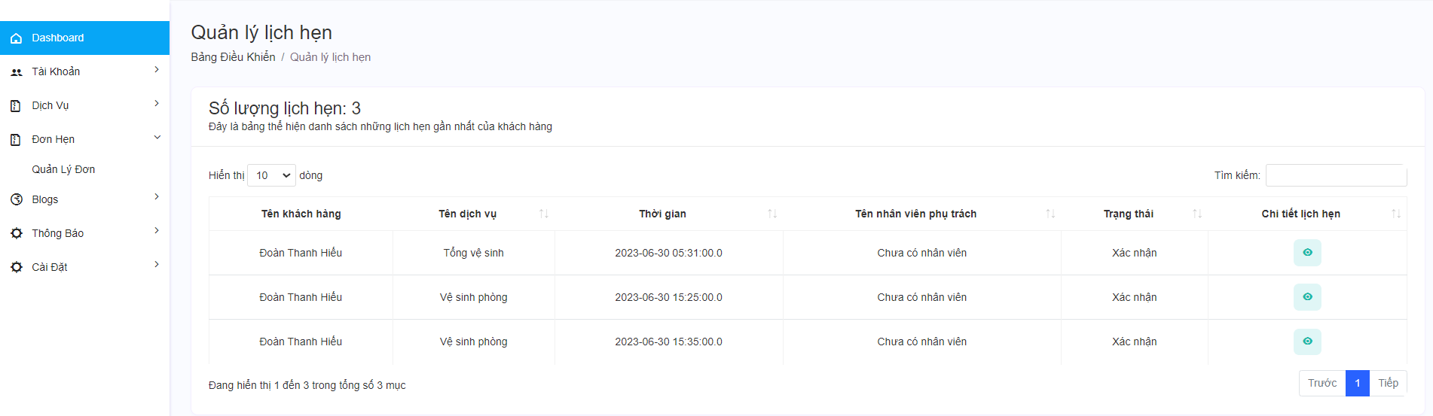

#### 11. The workflow for admins to Blog management

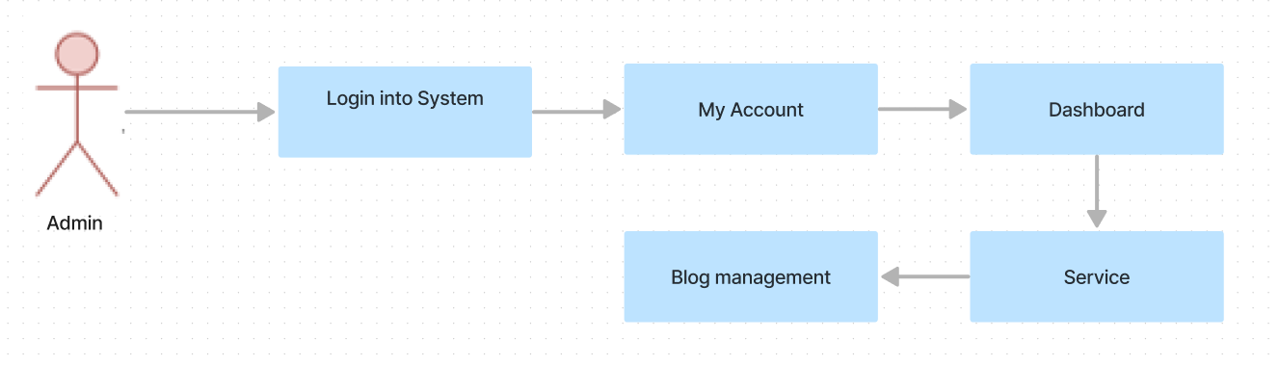

#### 12. The workflow for admins to create new Blog

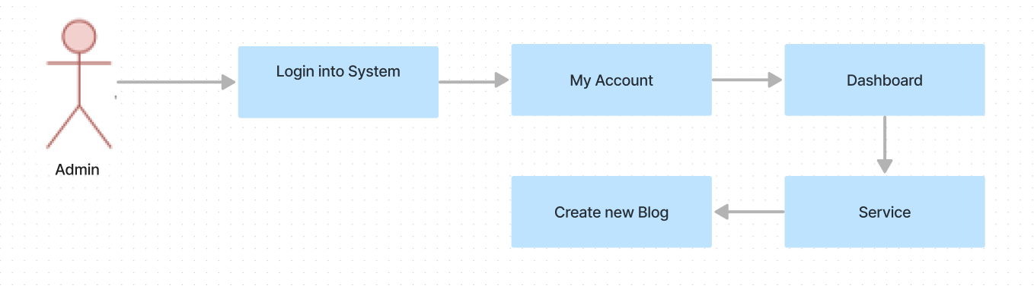

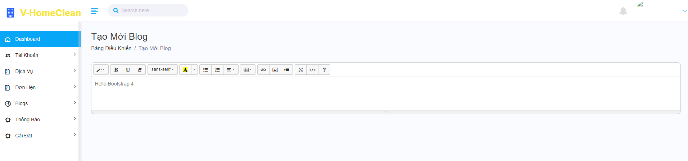

### **2. Manager**

#### 1. The workflow for a manager for tracking and managing data

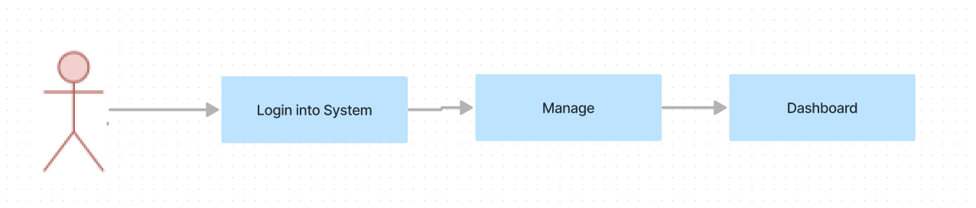

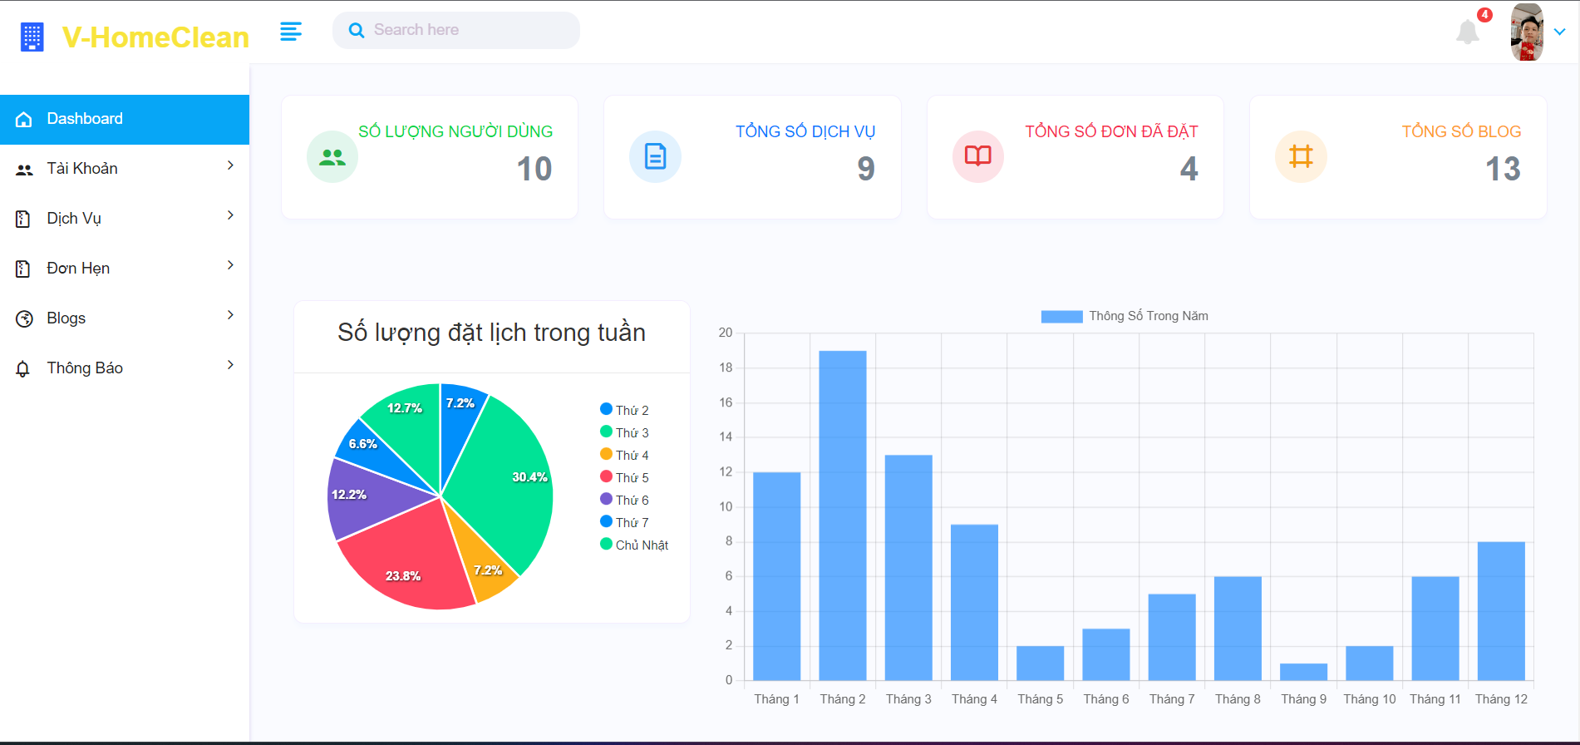

#### 2. The workflow for a manager to edit personal information



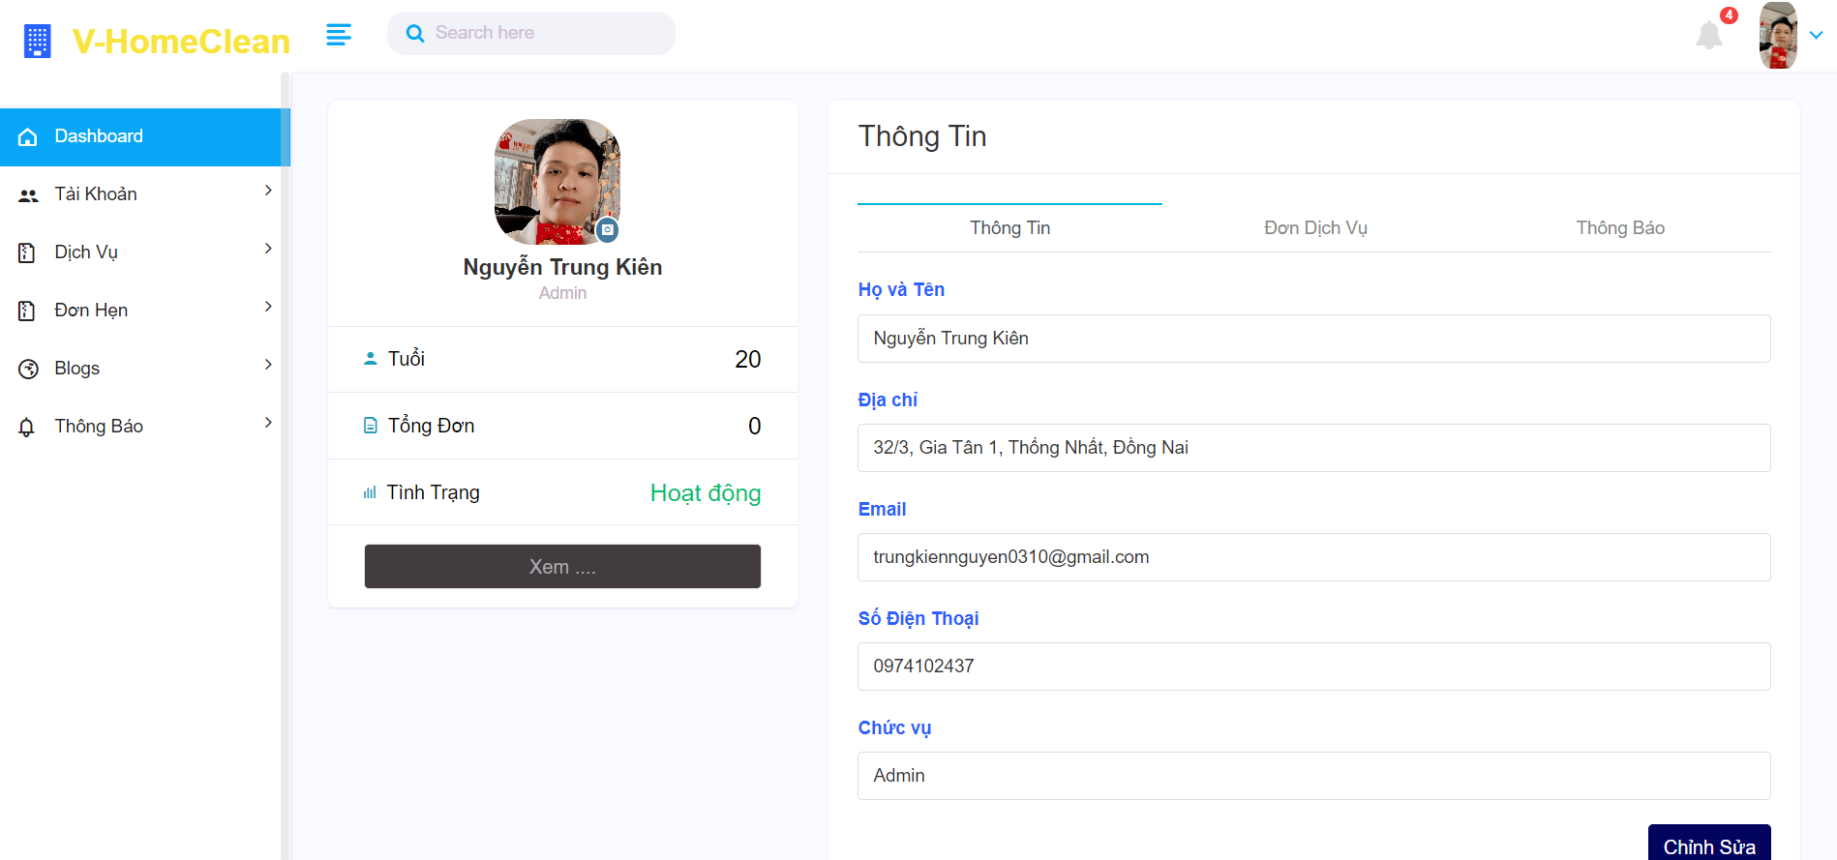

#### 3. The workflow for a manager to view a list of users.

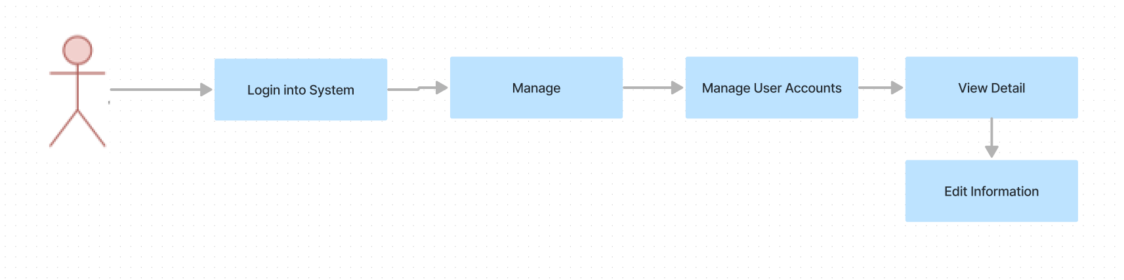

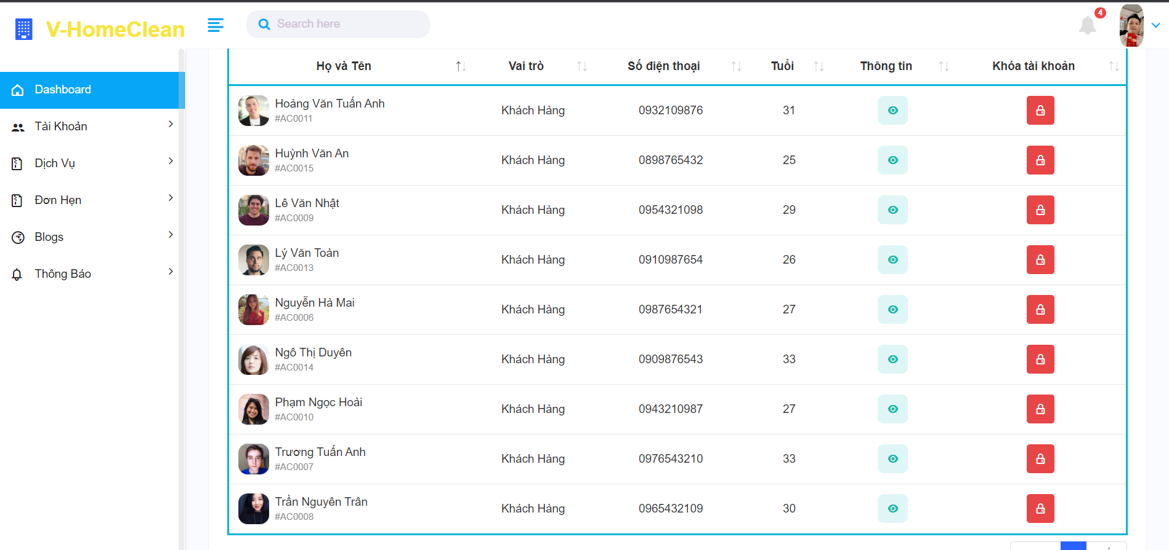

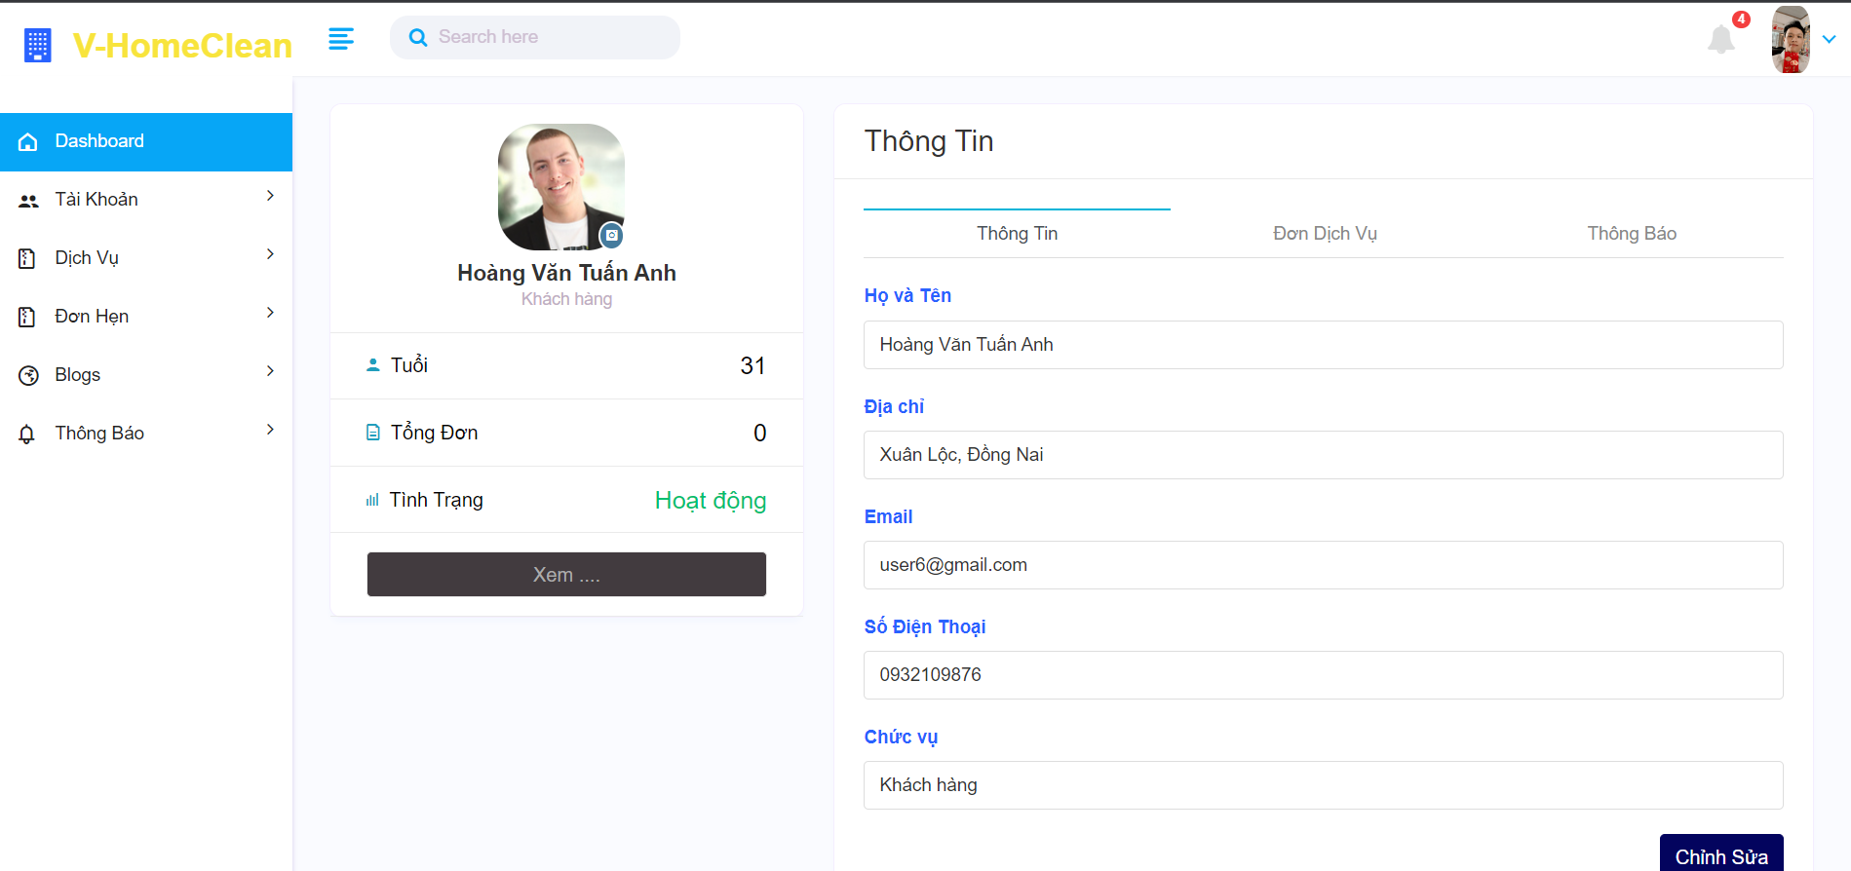

#### 4. The workflow for a manager to view a list of staffs.

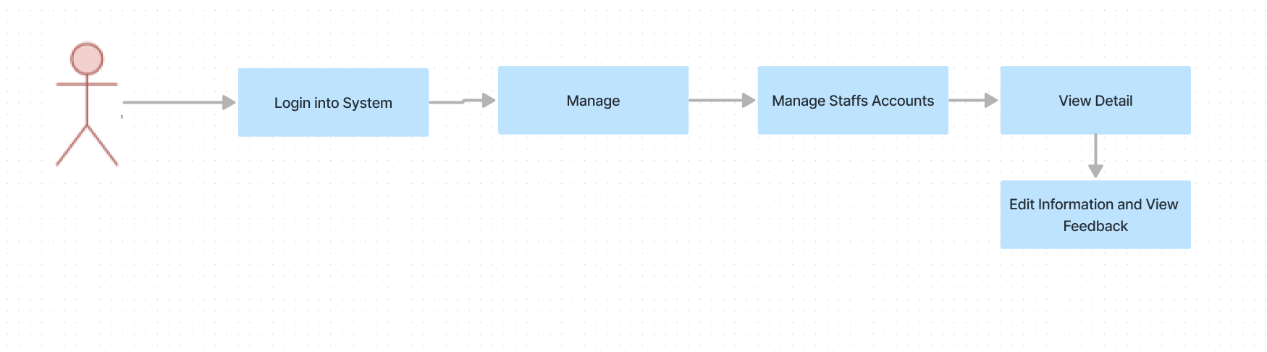

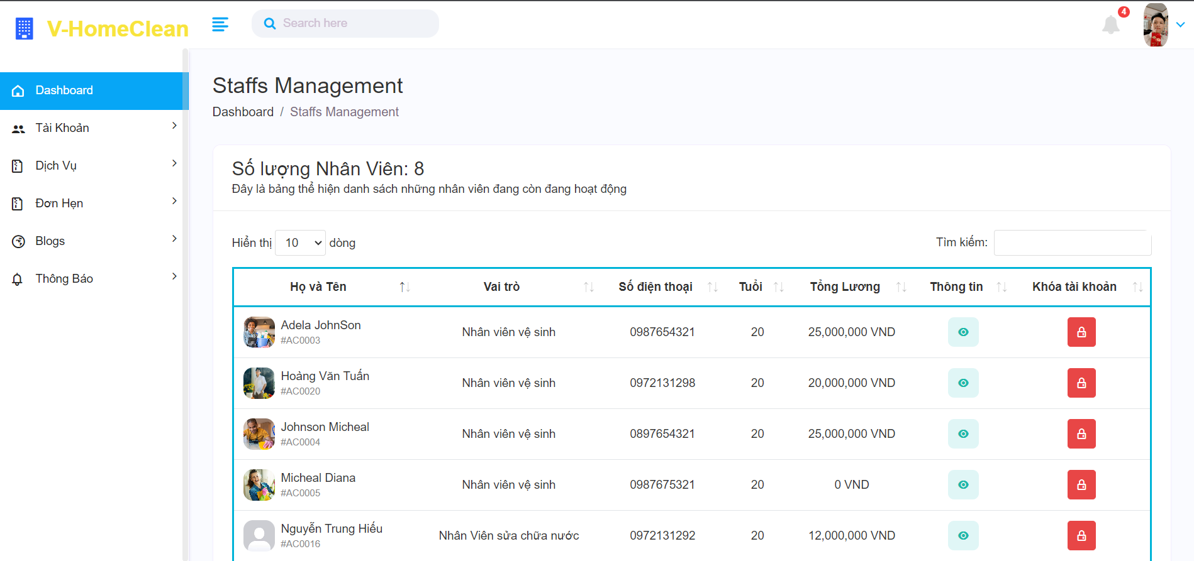

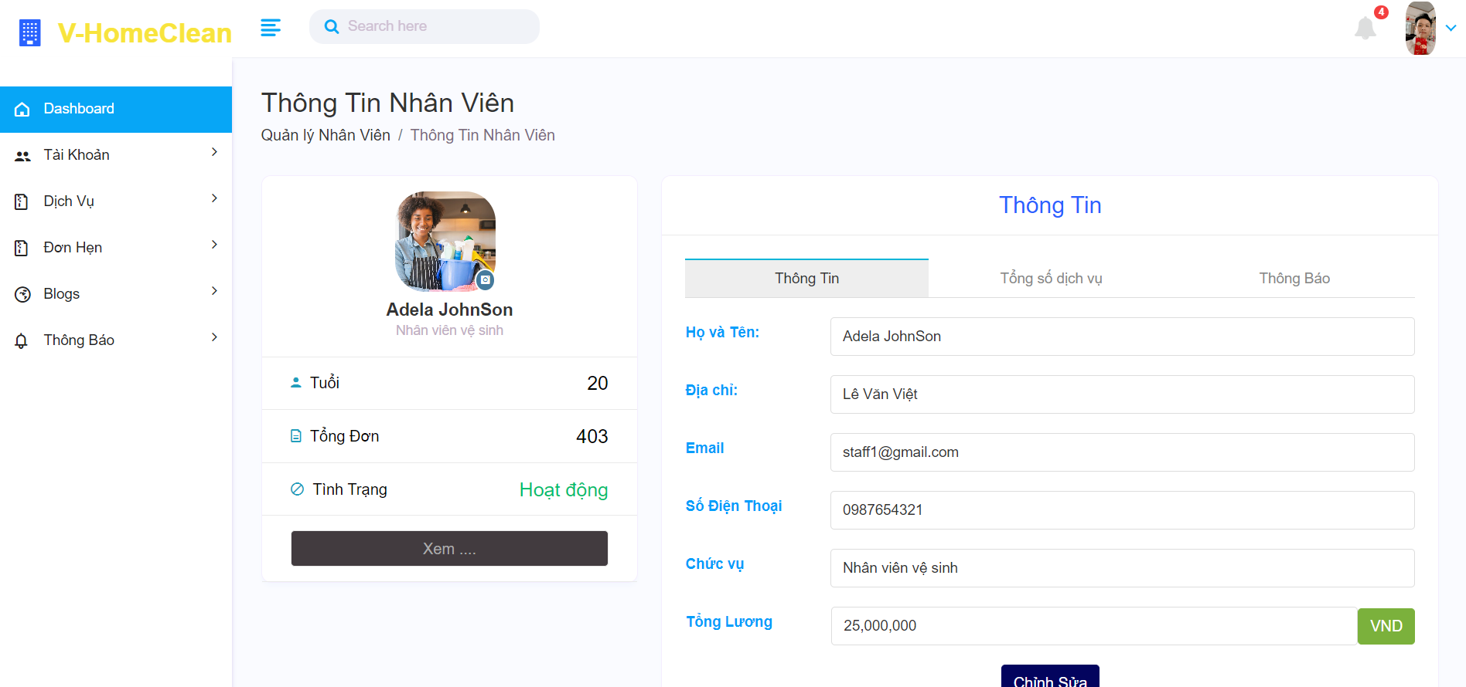

#### 5. The workflow for a manager to view a list of blocked Accounts.

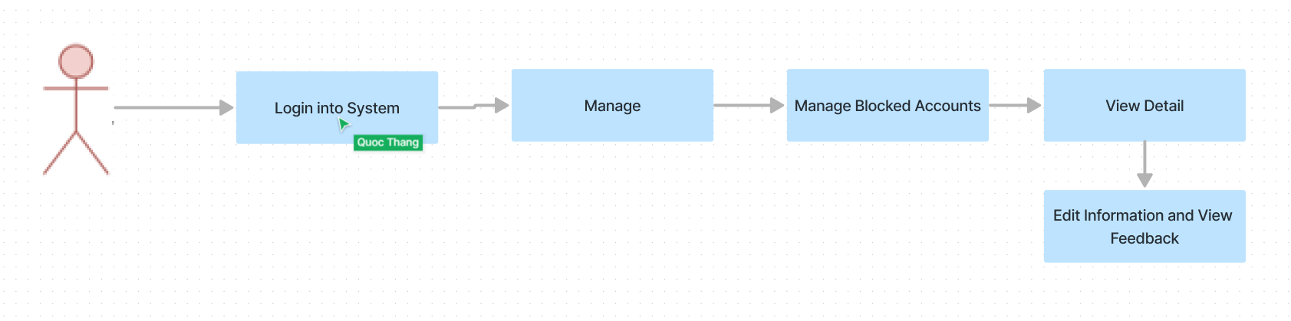

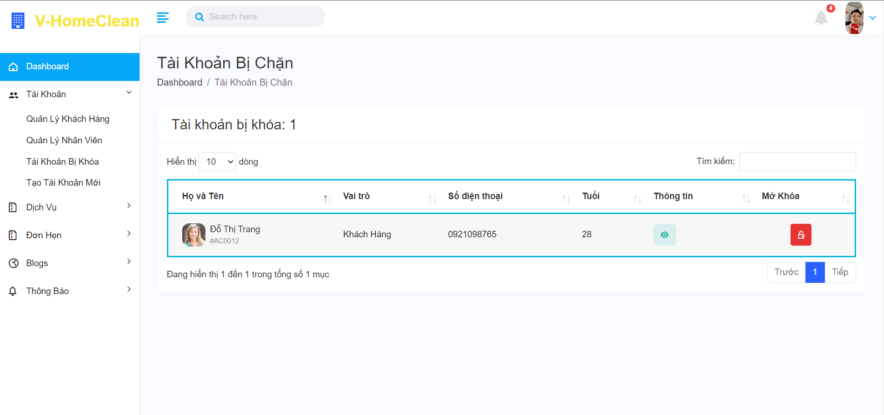

#### 6. The workflow for a manager to manage services.

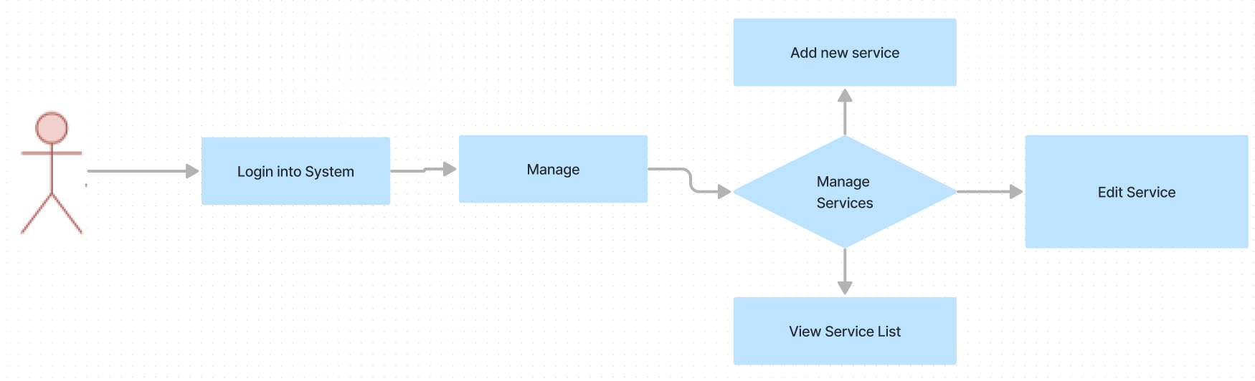

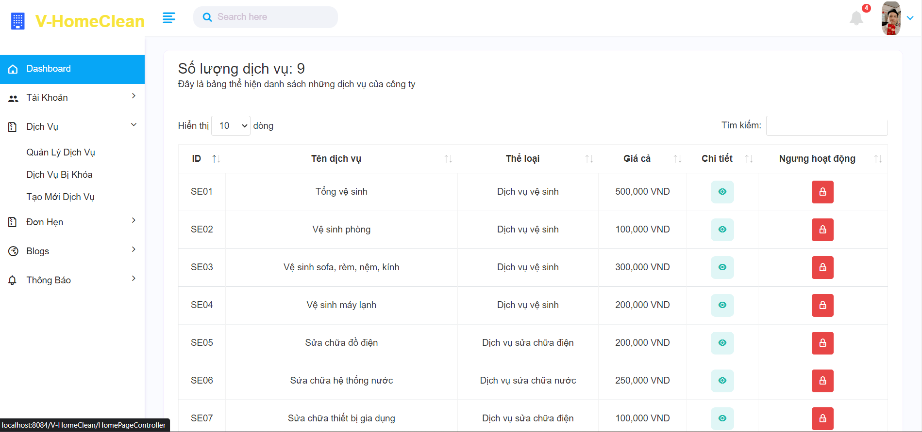

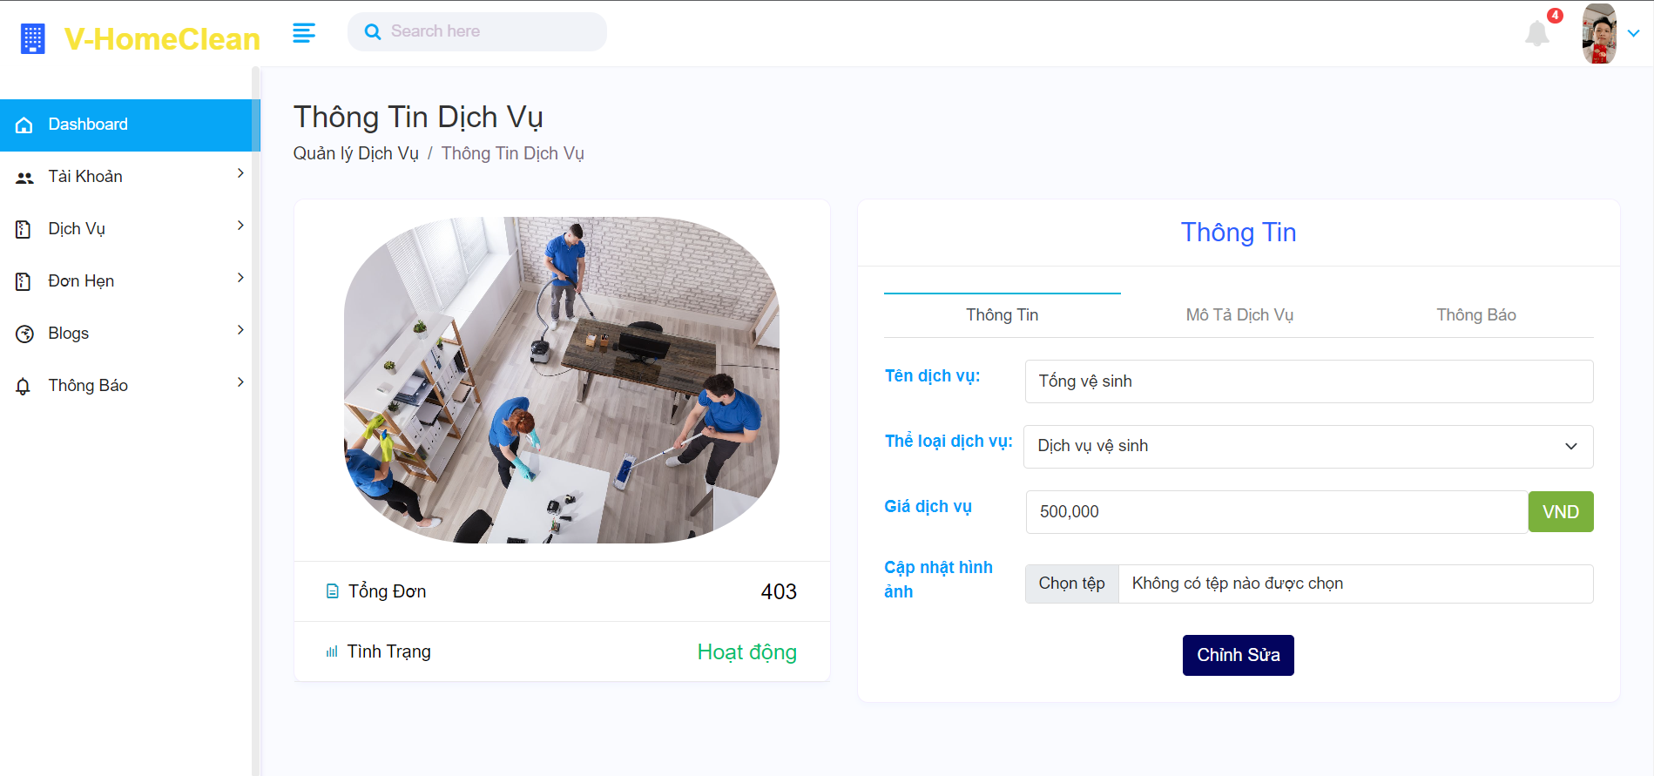

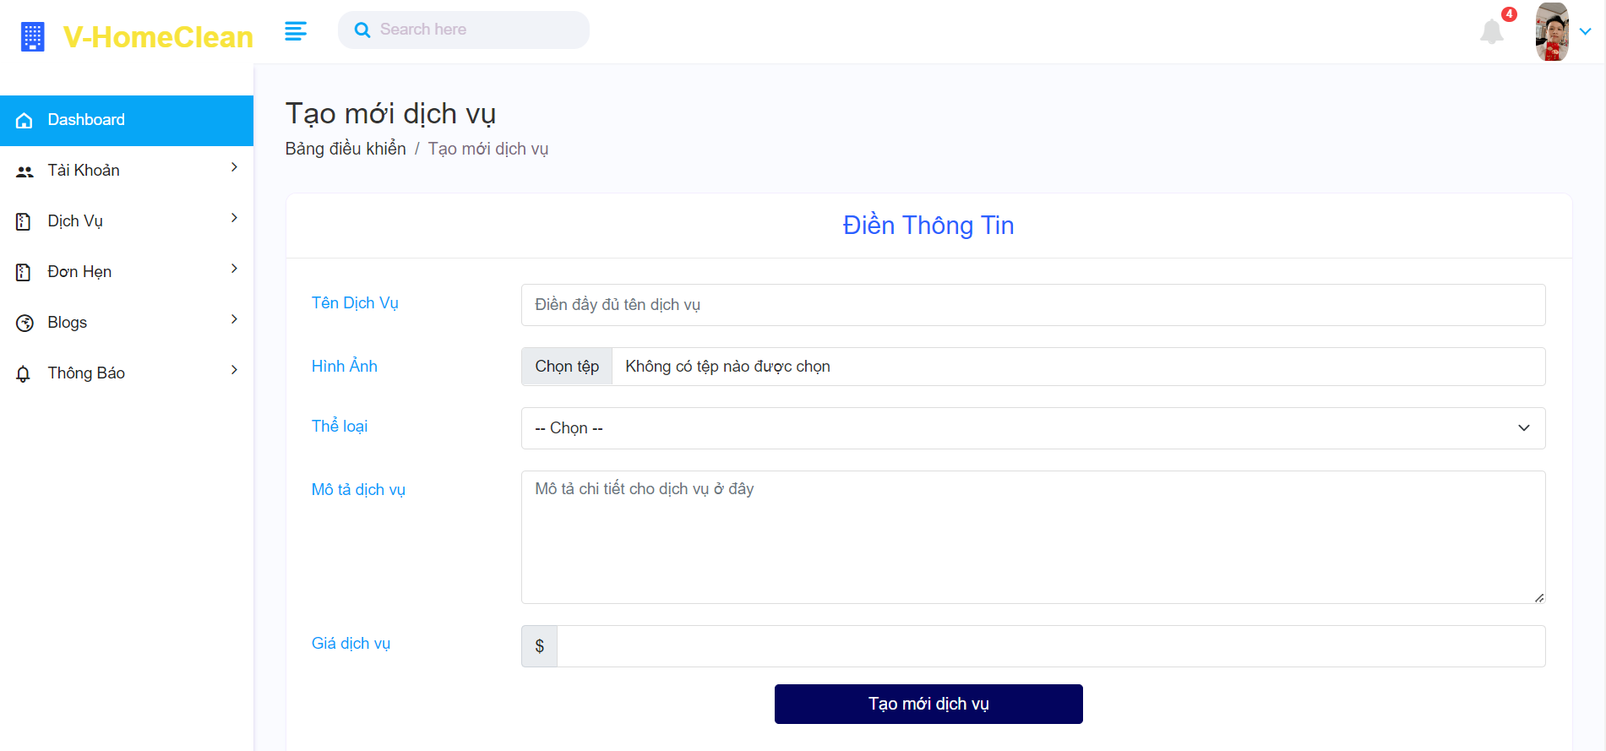

#### 7. The workflow for a manager to manage booking orders.

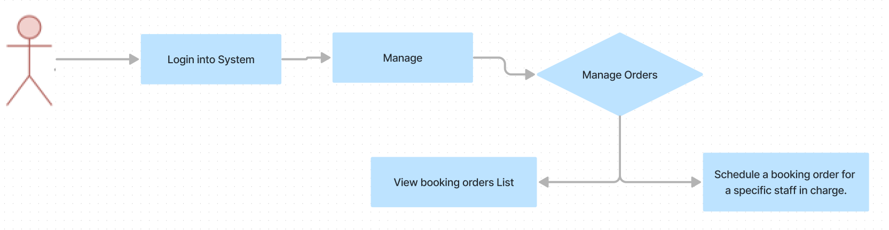

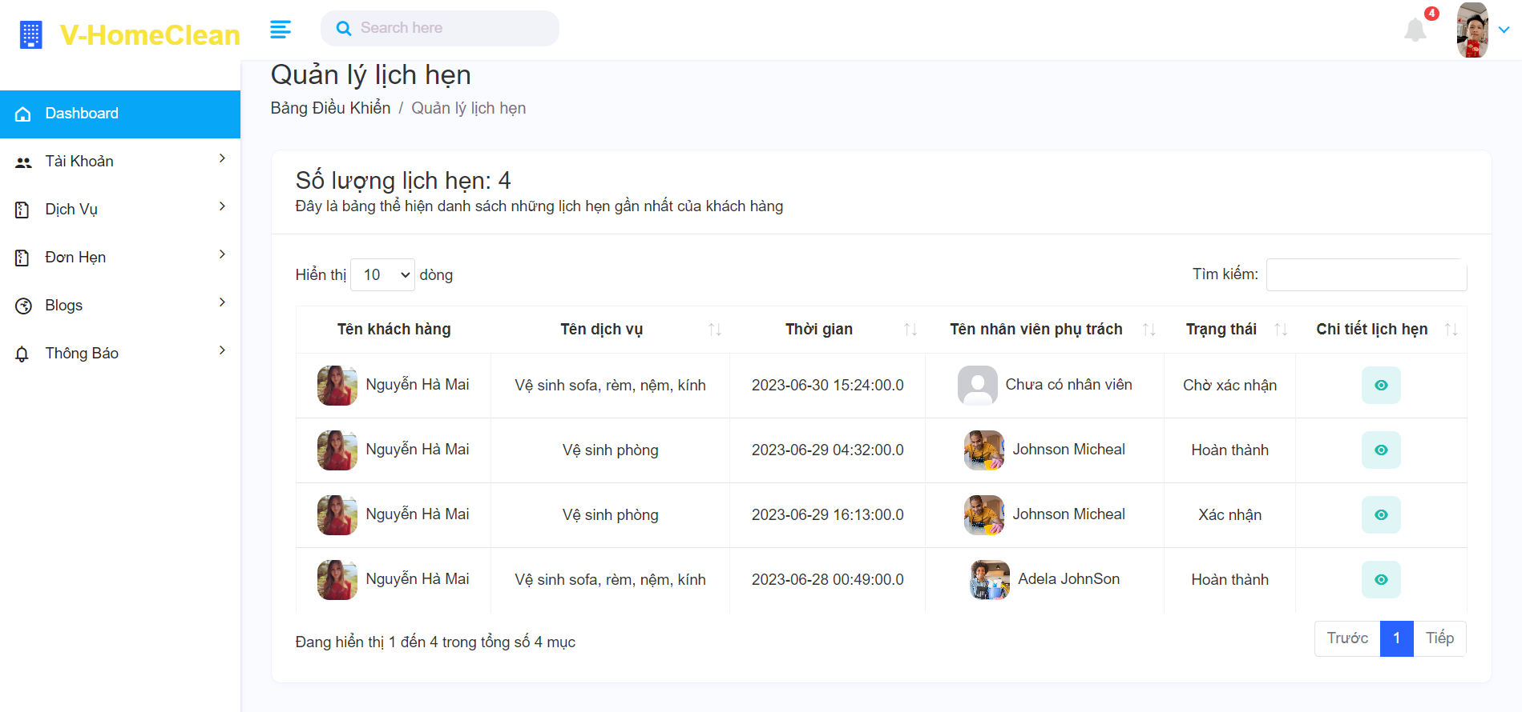

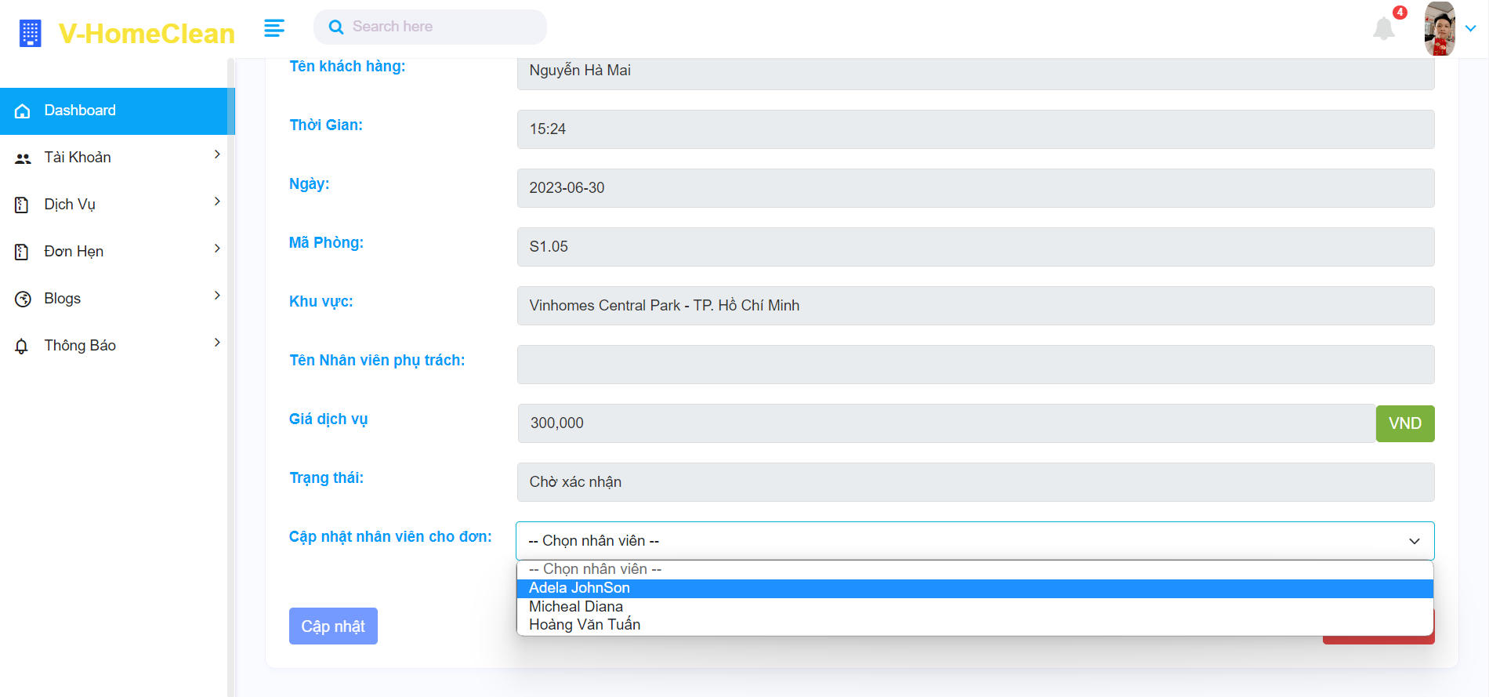

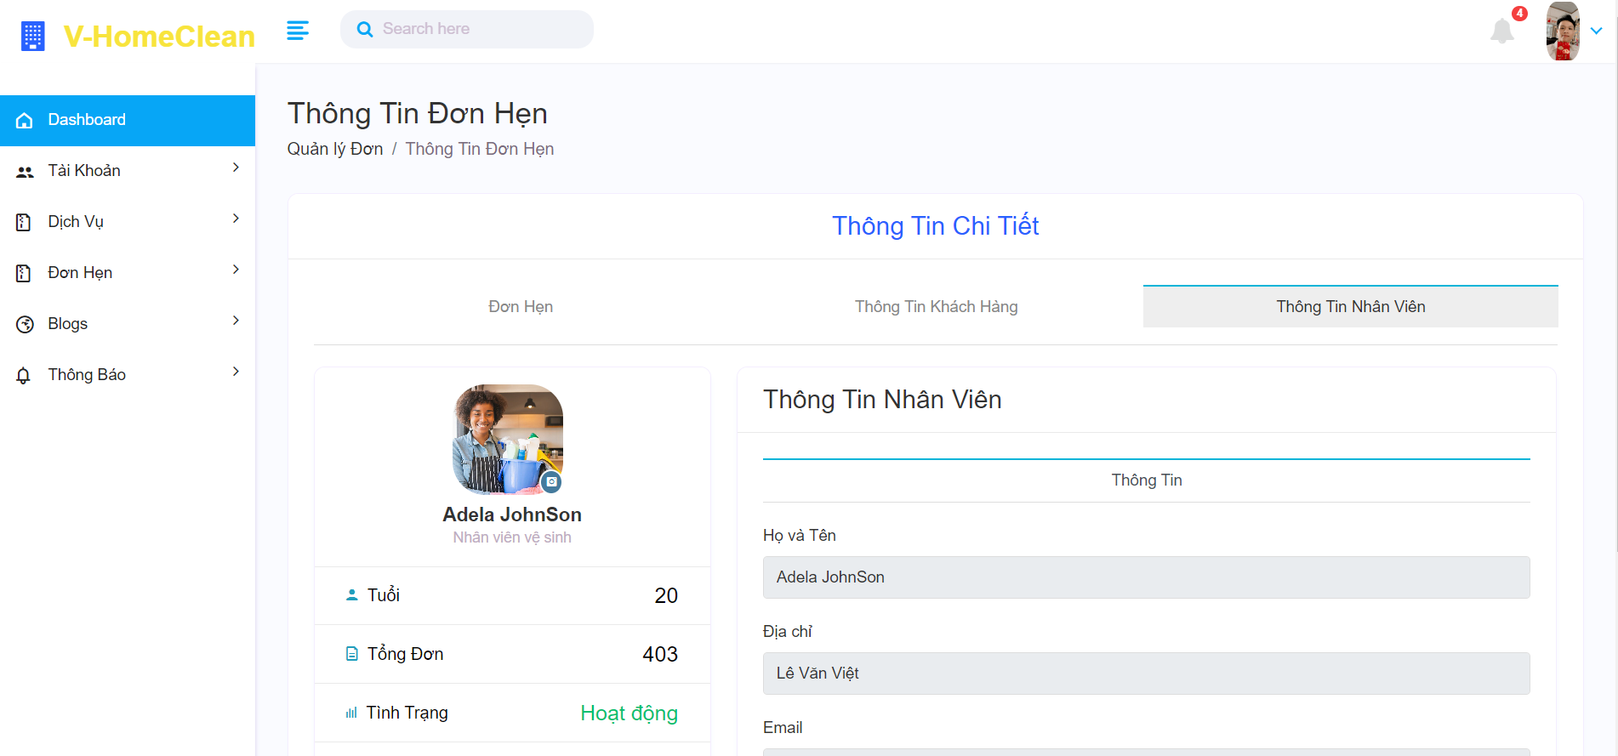

#### 8. The workflow for a manager to manage blogs.

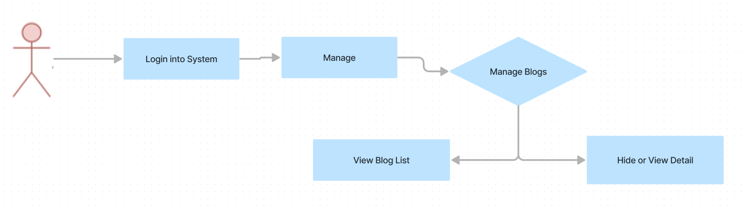

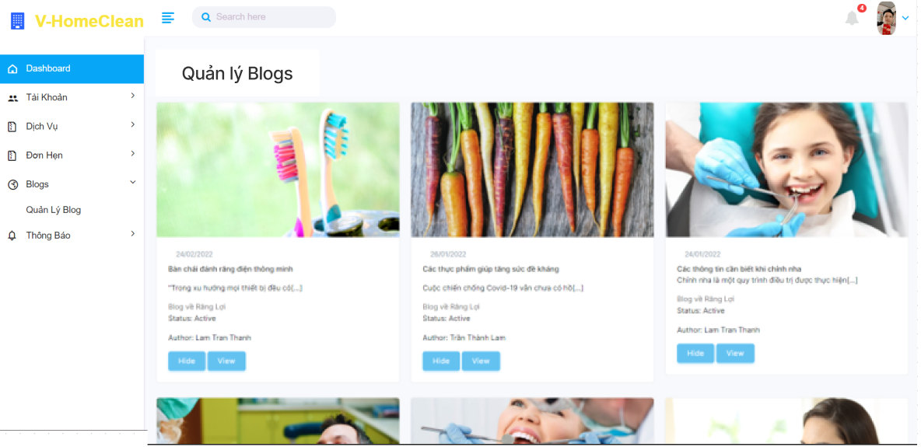

#### 9. The workflow for a manager to create new account for any.

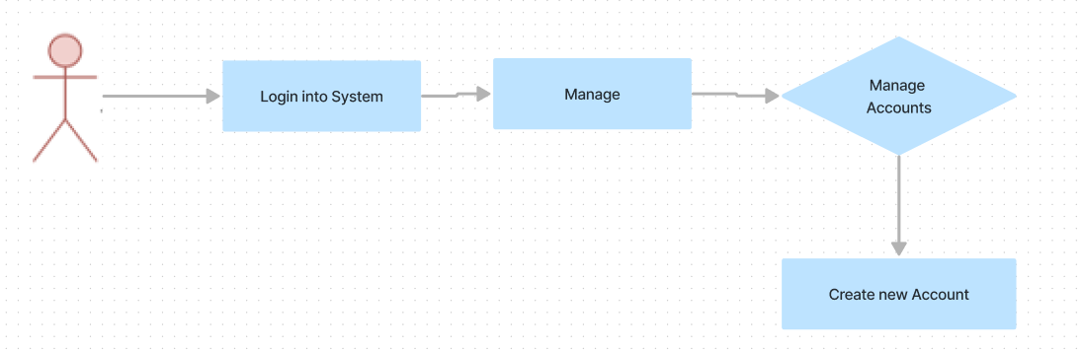

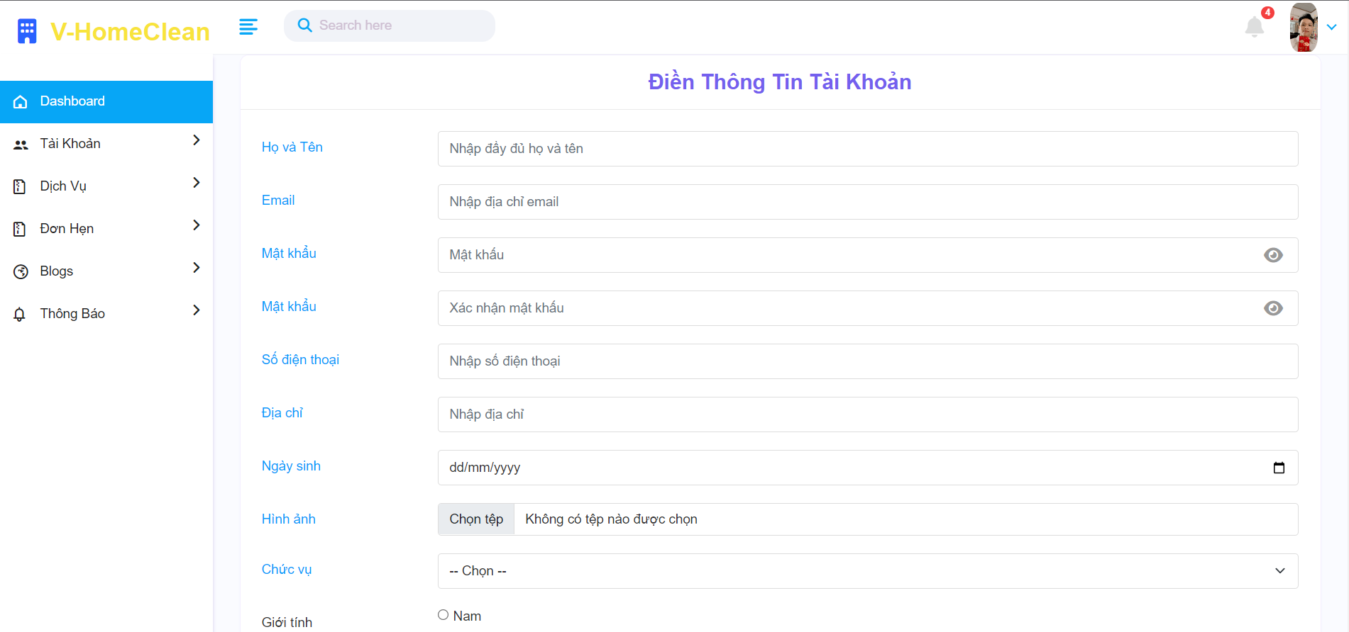

### 3. Staff

#### 1. The workflow for the staff to edit the staff's information.

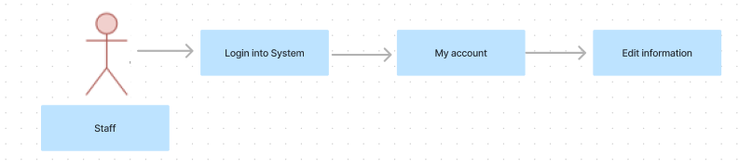

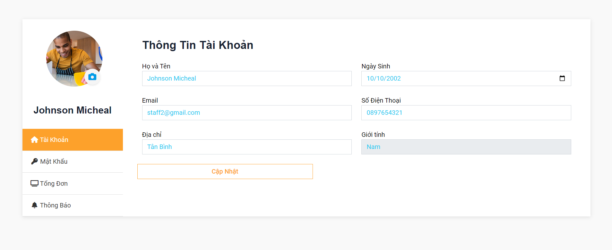

#### 2. The workflow for the staff to view the service list.

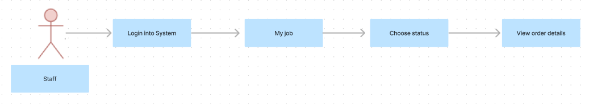

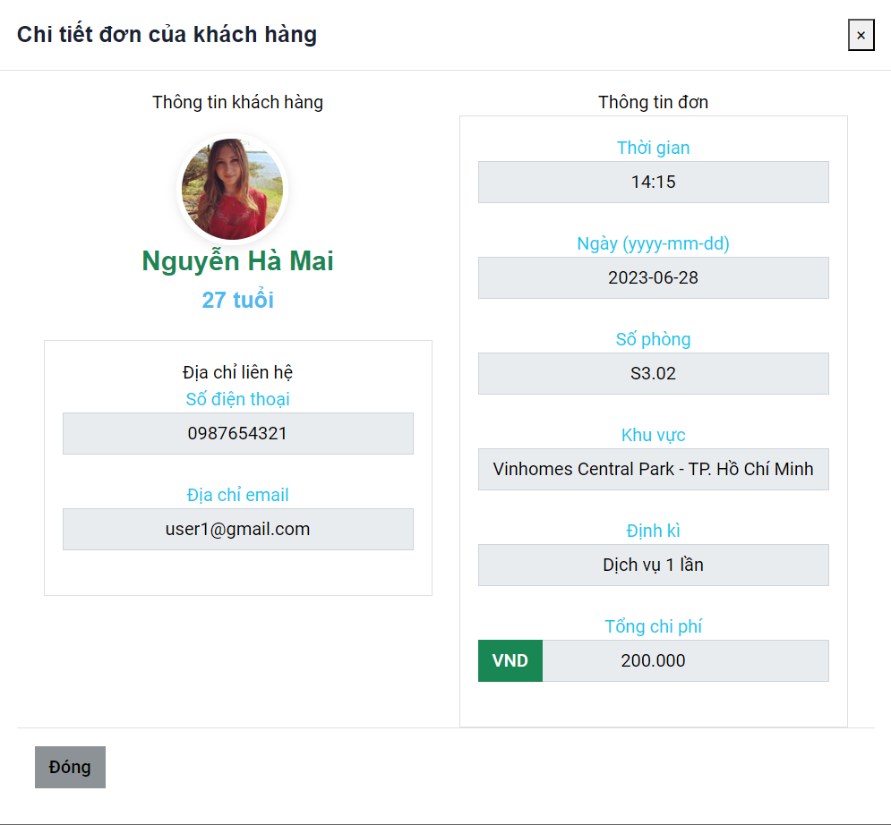

#### 3. The workflow for the staff to view the feedback.

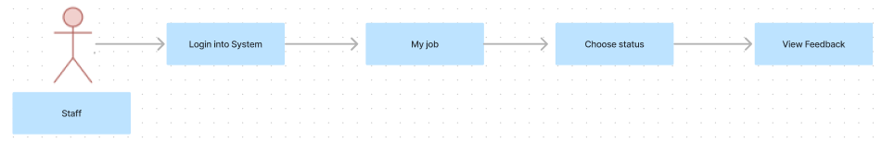

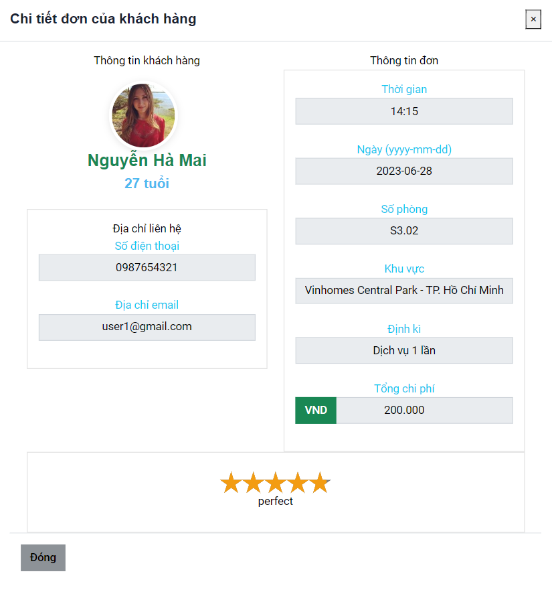

### 4. Customer

#### 1. Workflow customer order service

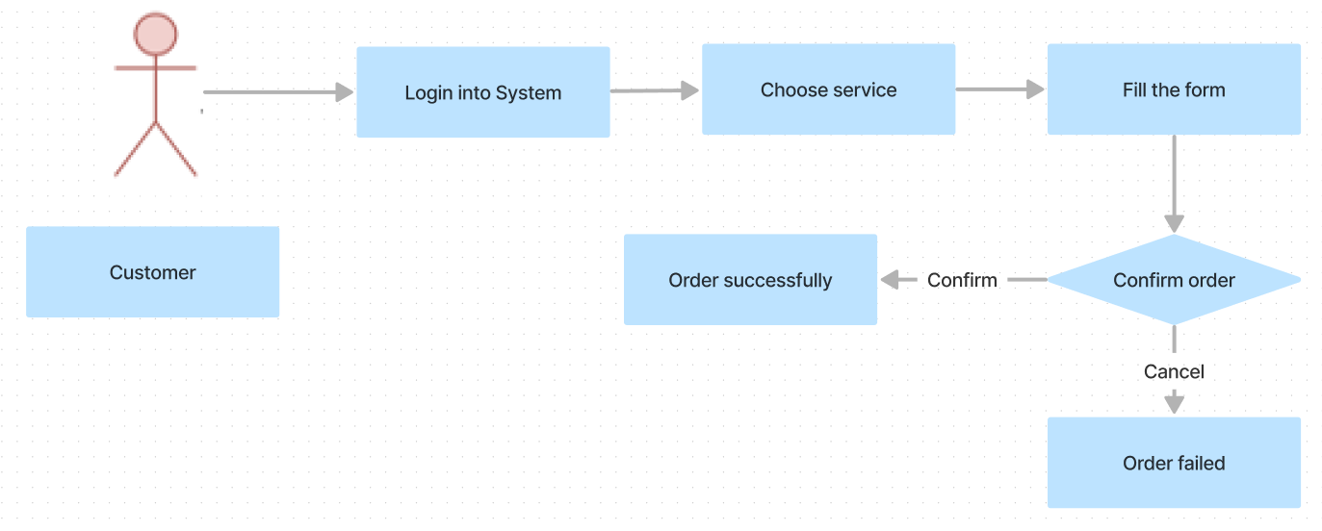

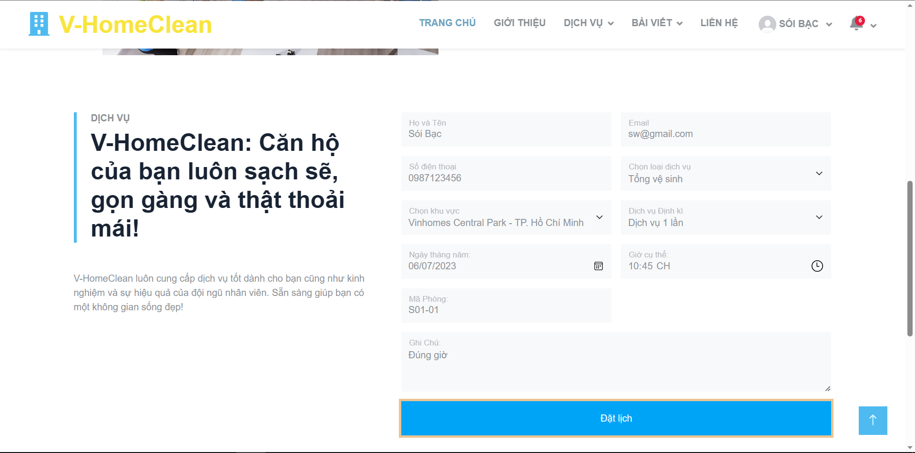

#### 2. Workflow customer check order detail

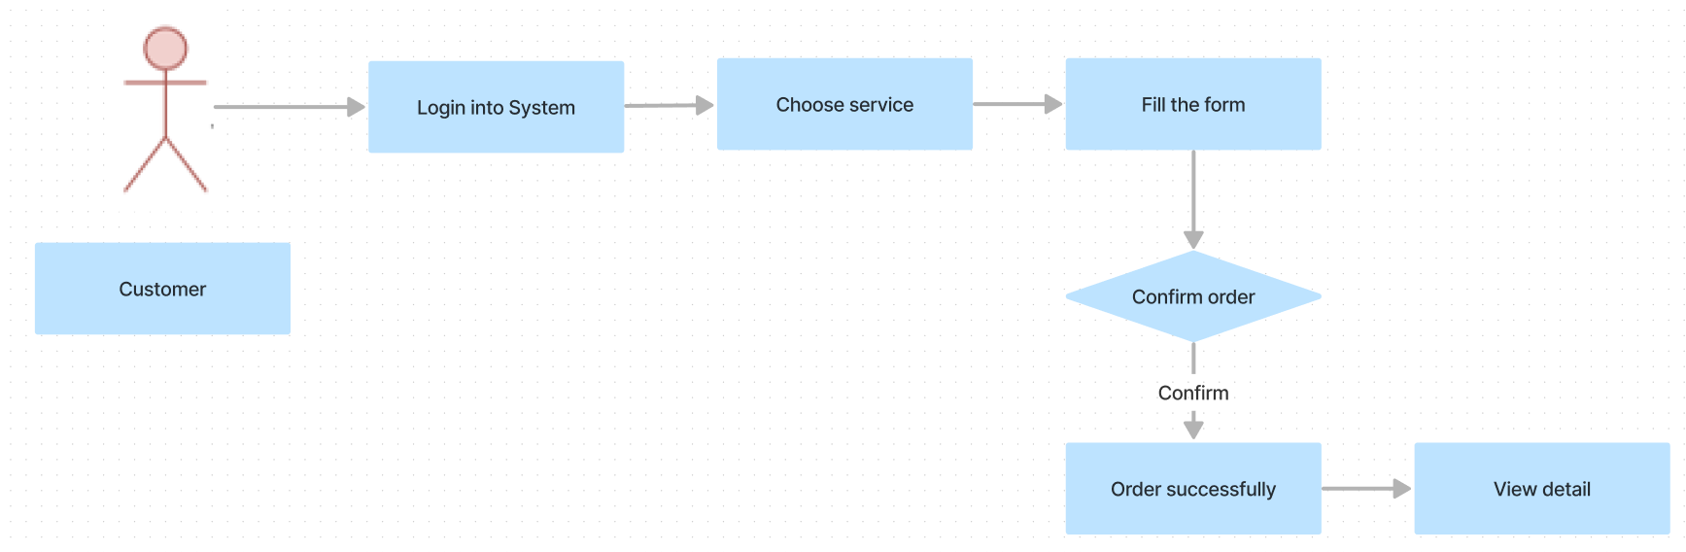

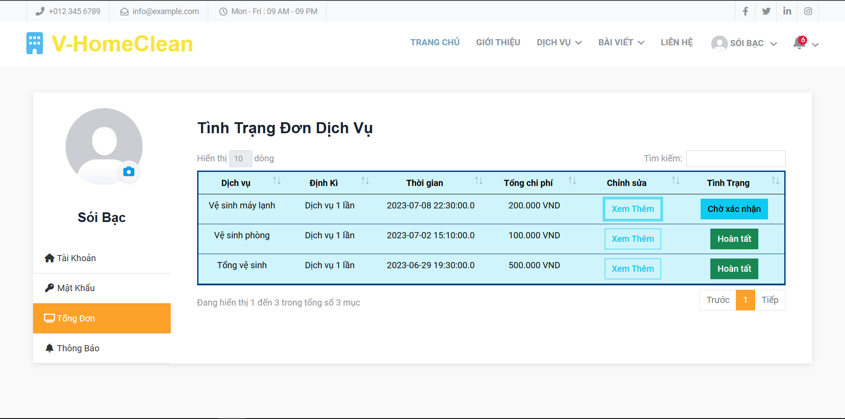

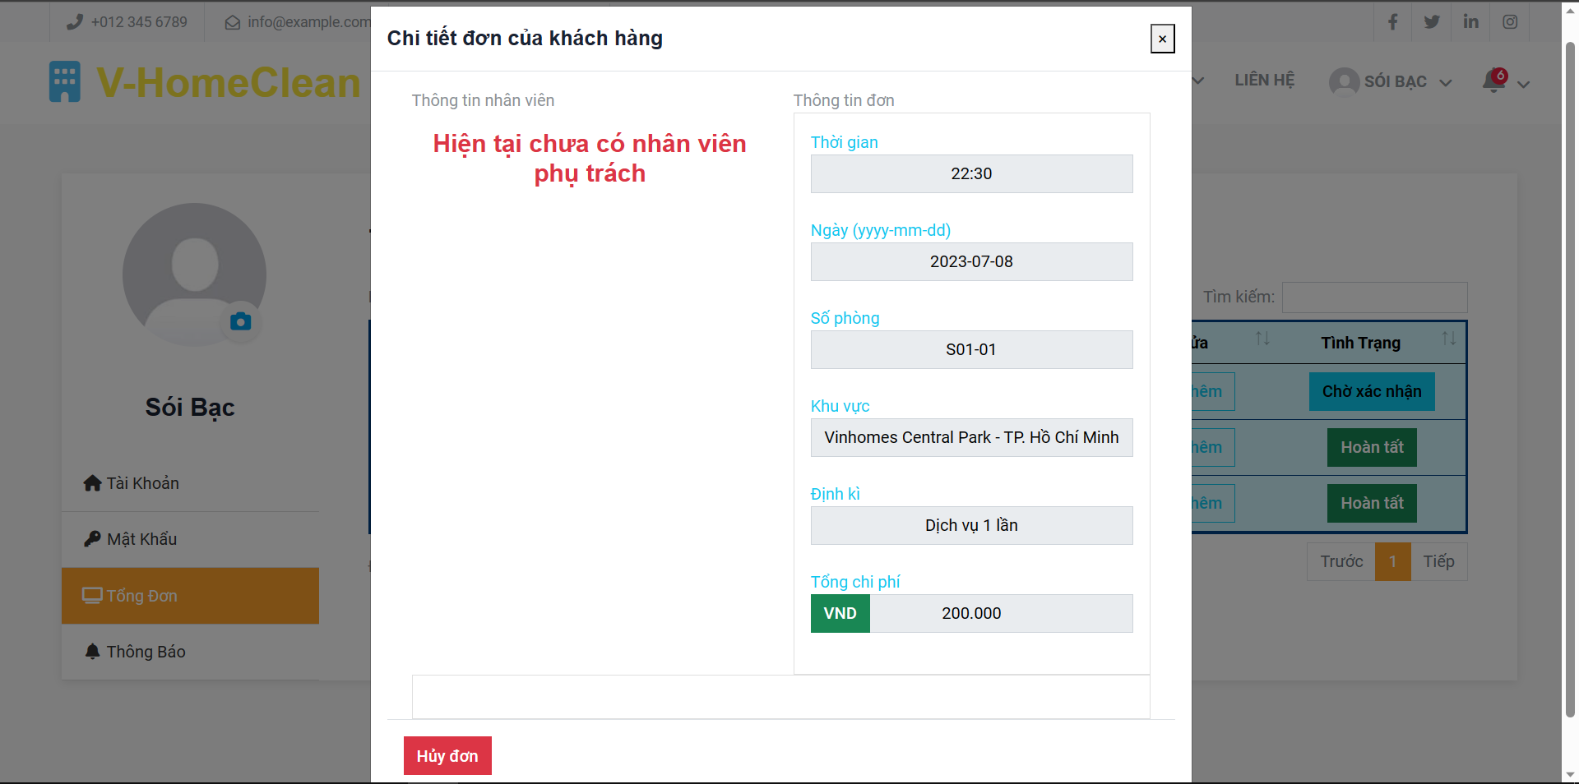

#### 3. Workflow customer update account information

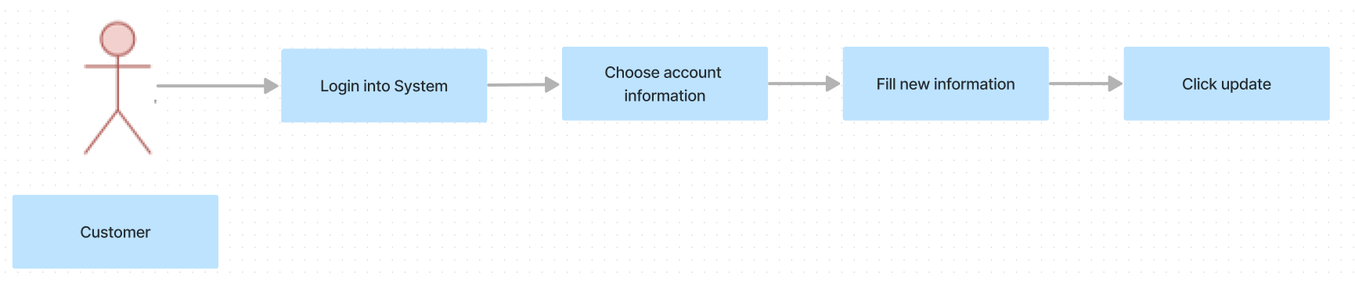

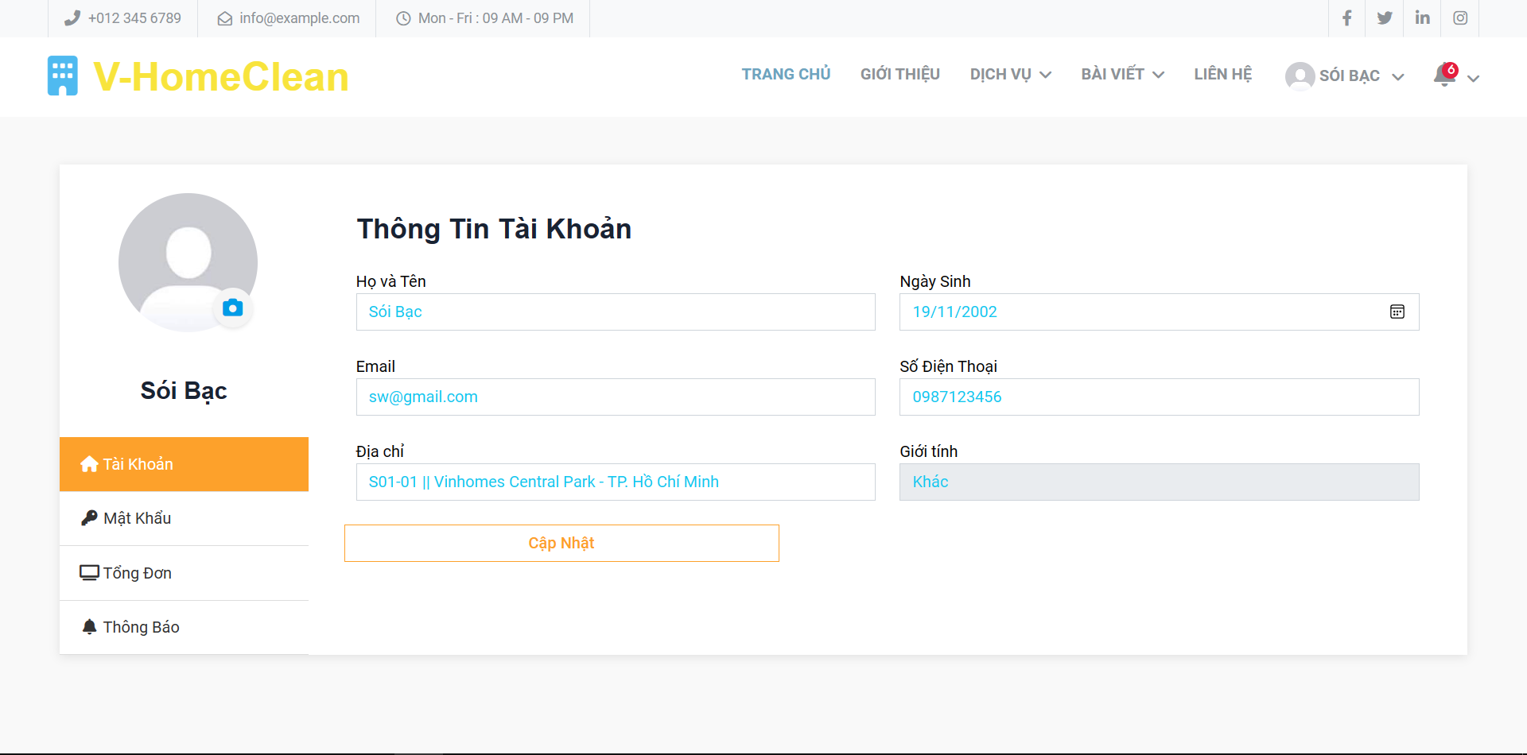

#### 4. Workflow customer feedback

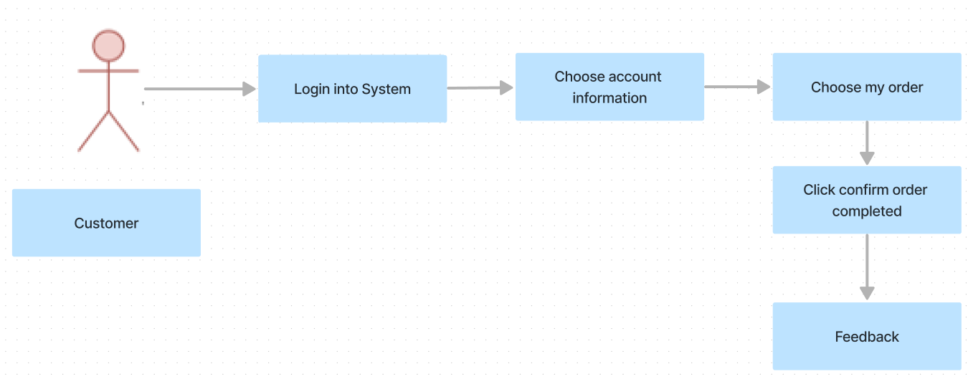

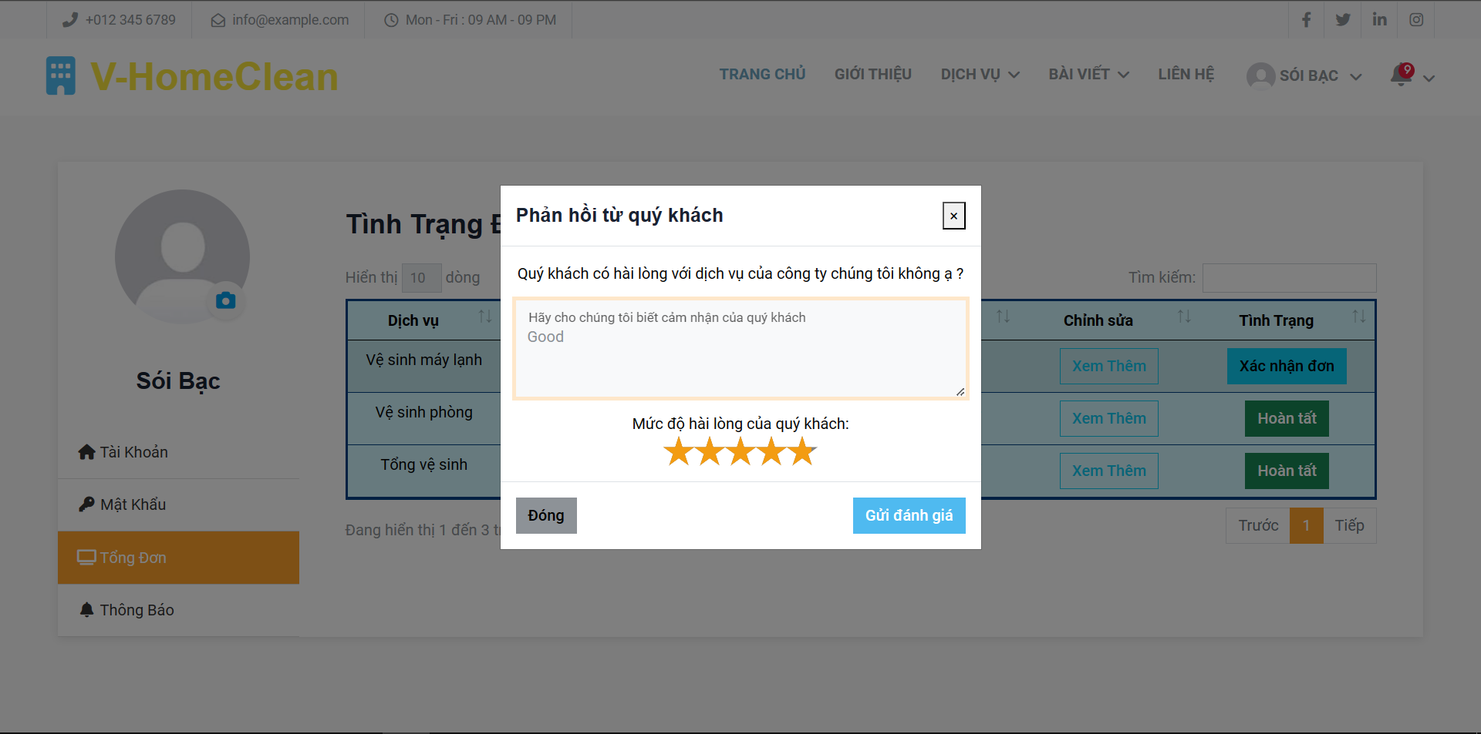

### 

### 

### 5. Guest

#### 1. The workflow for guests to view the home page.

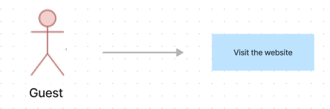



#### 

#### 

#### 2. The workflow for guests to view the services list.

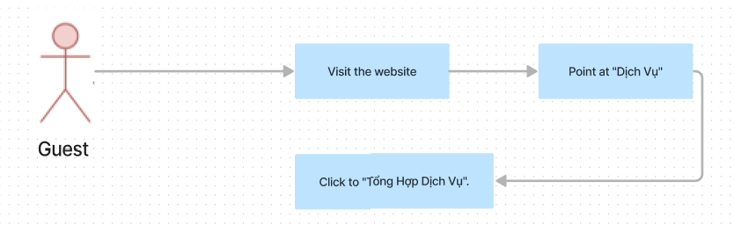

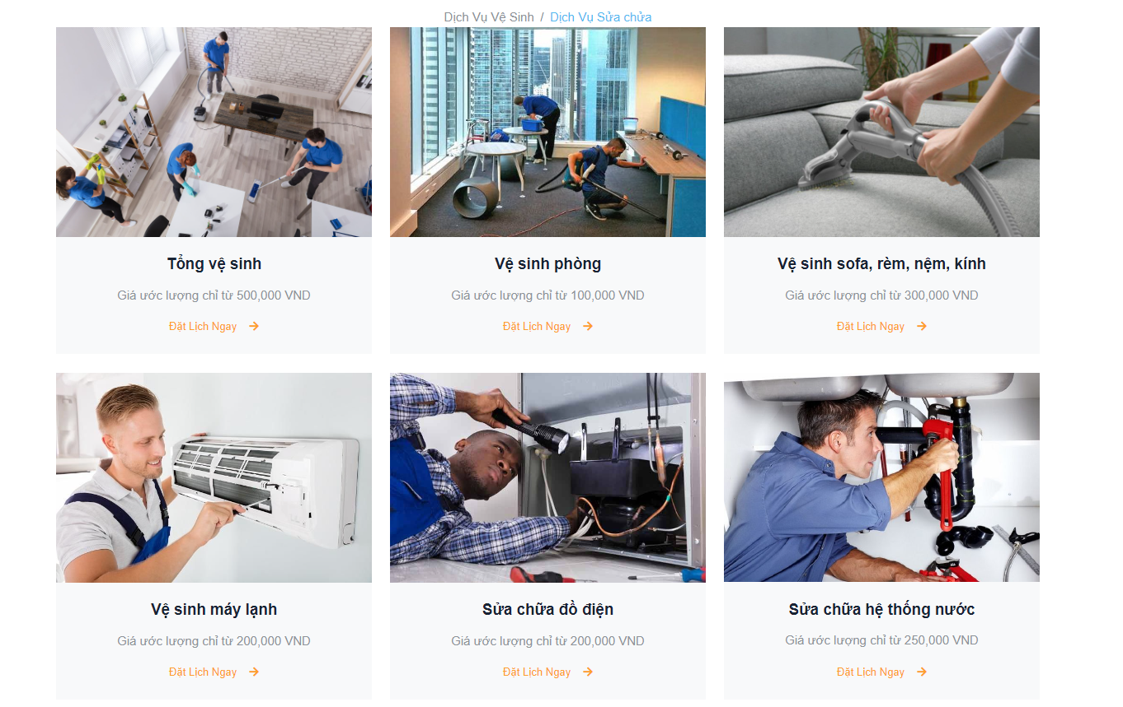

#### 3. The workflow for guests to view the blogs list.

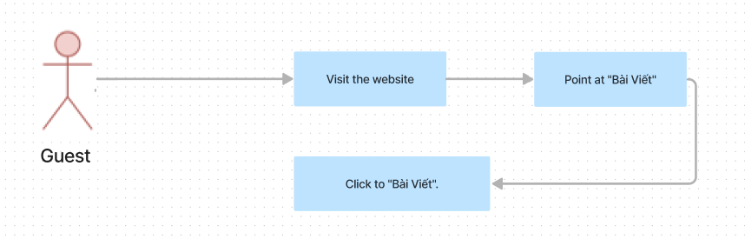

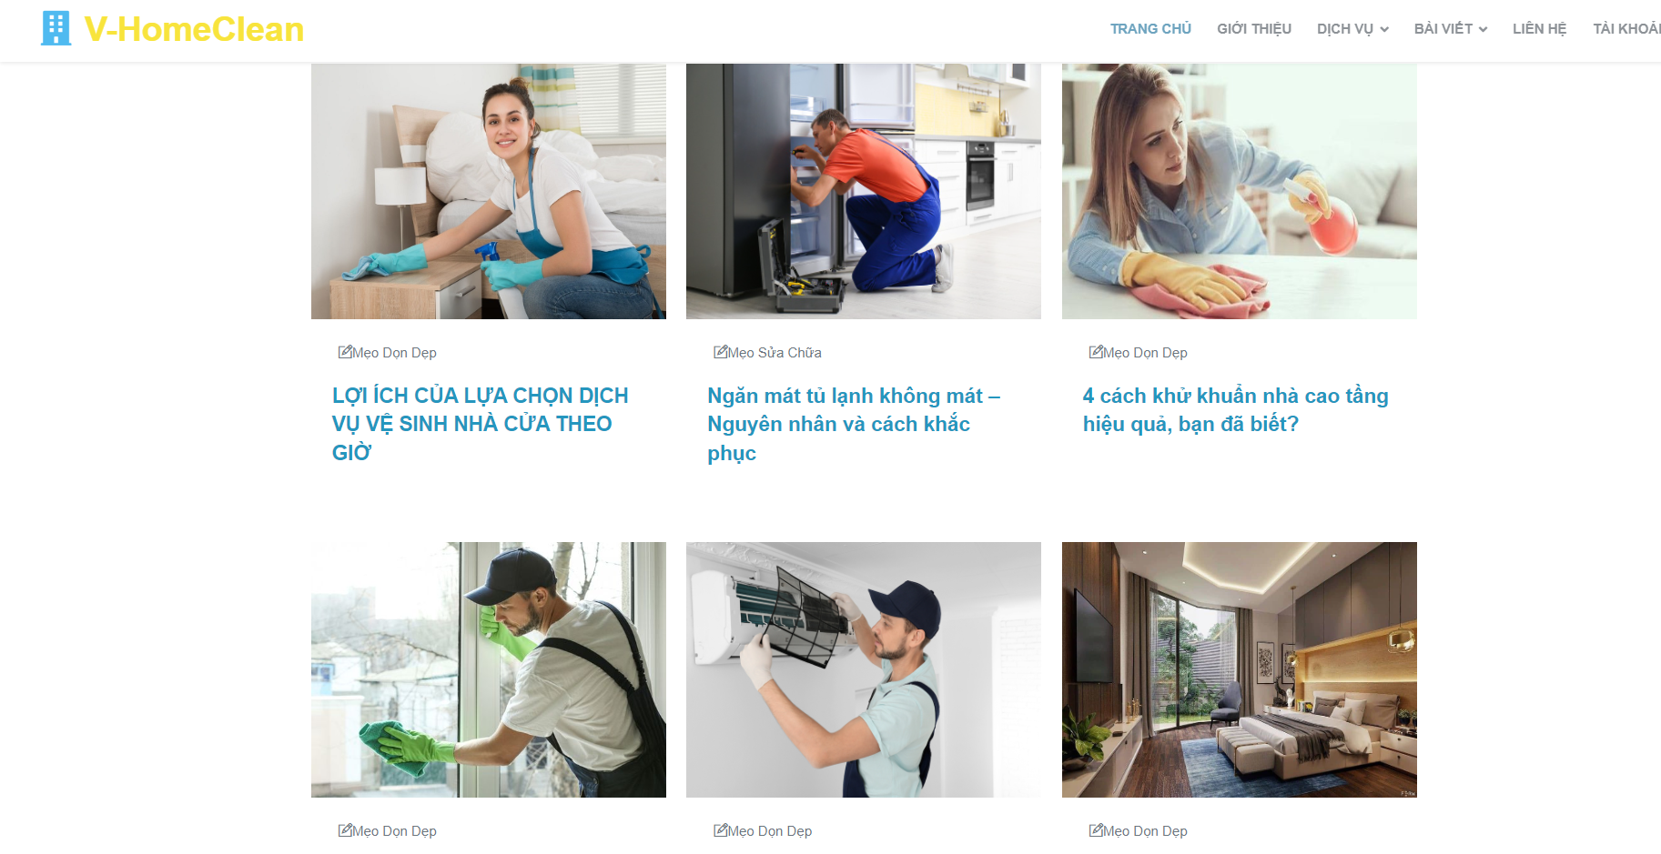

#### 4. The workflow for guests to view the blogs in detail and comment on each blog.

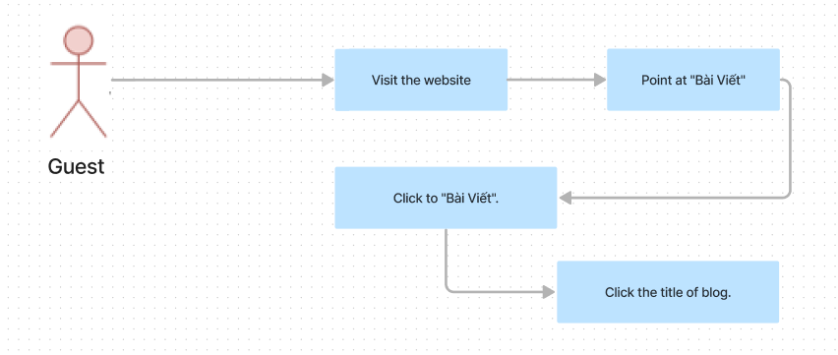



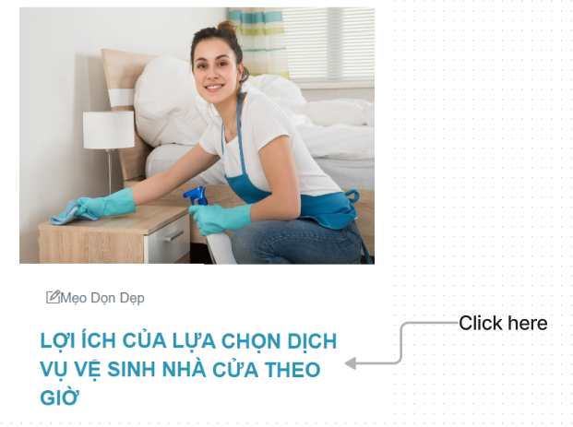

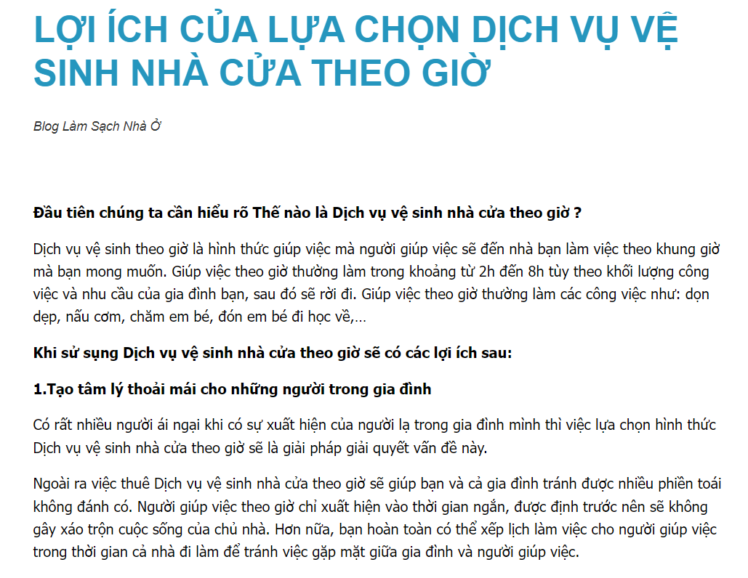

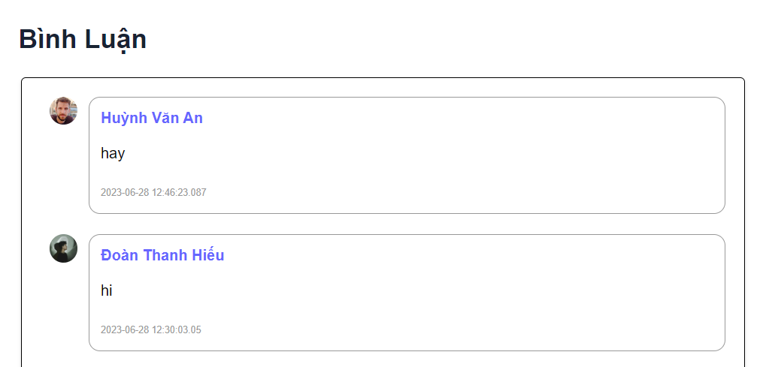

#### 5. The workflow for guests to view and register members.

